Step 1: Access VPC control panel

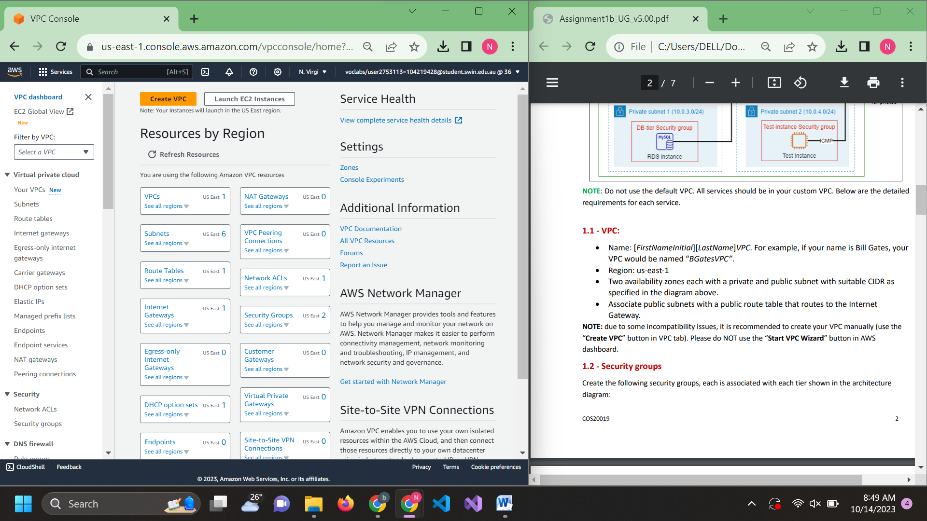

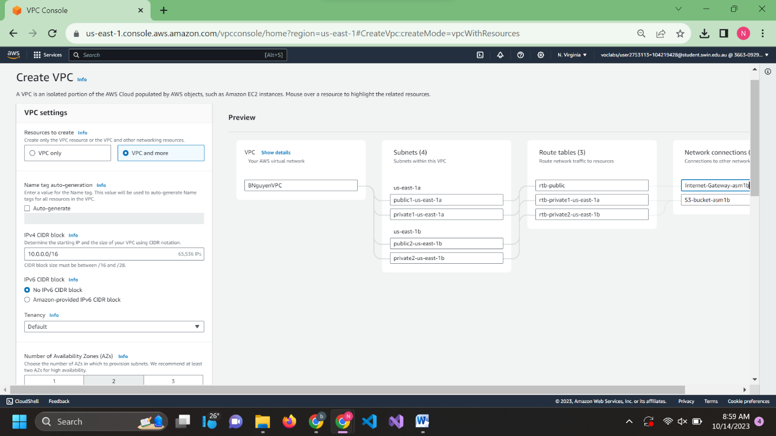Step 2: Create a VPC

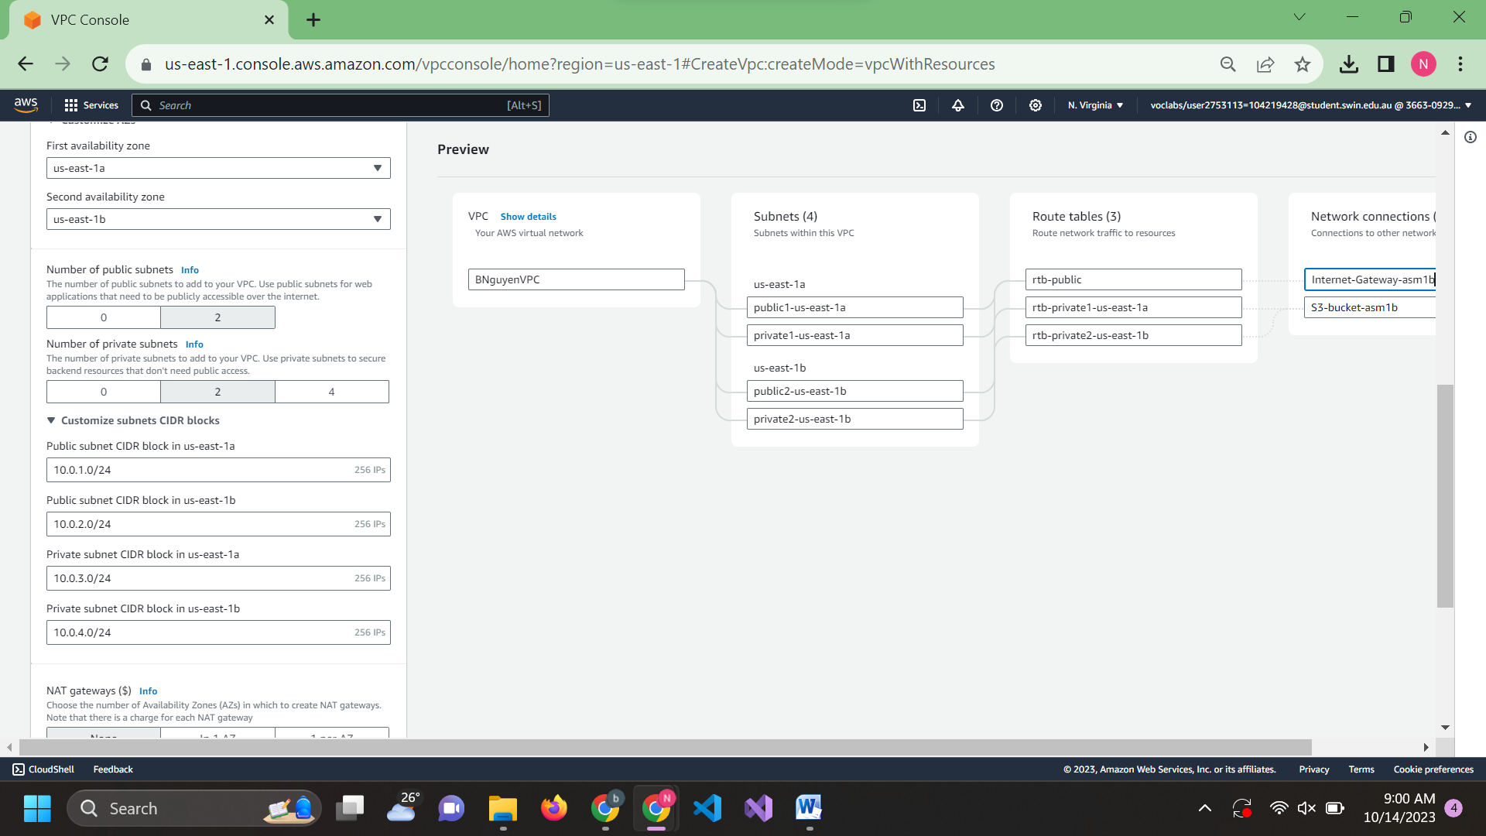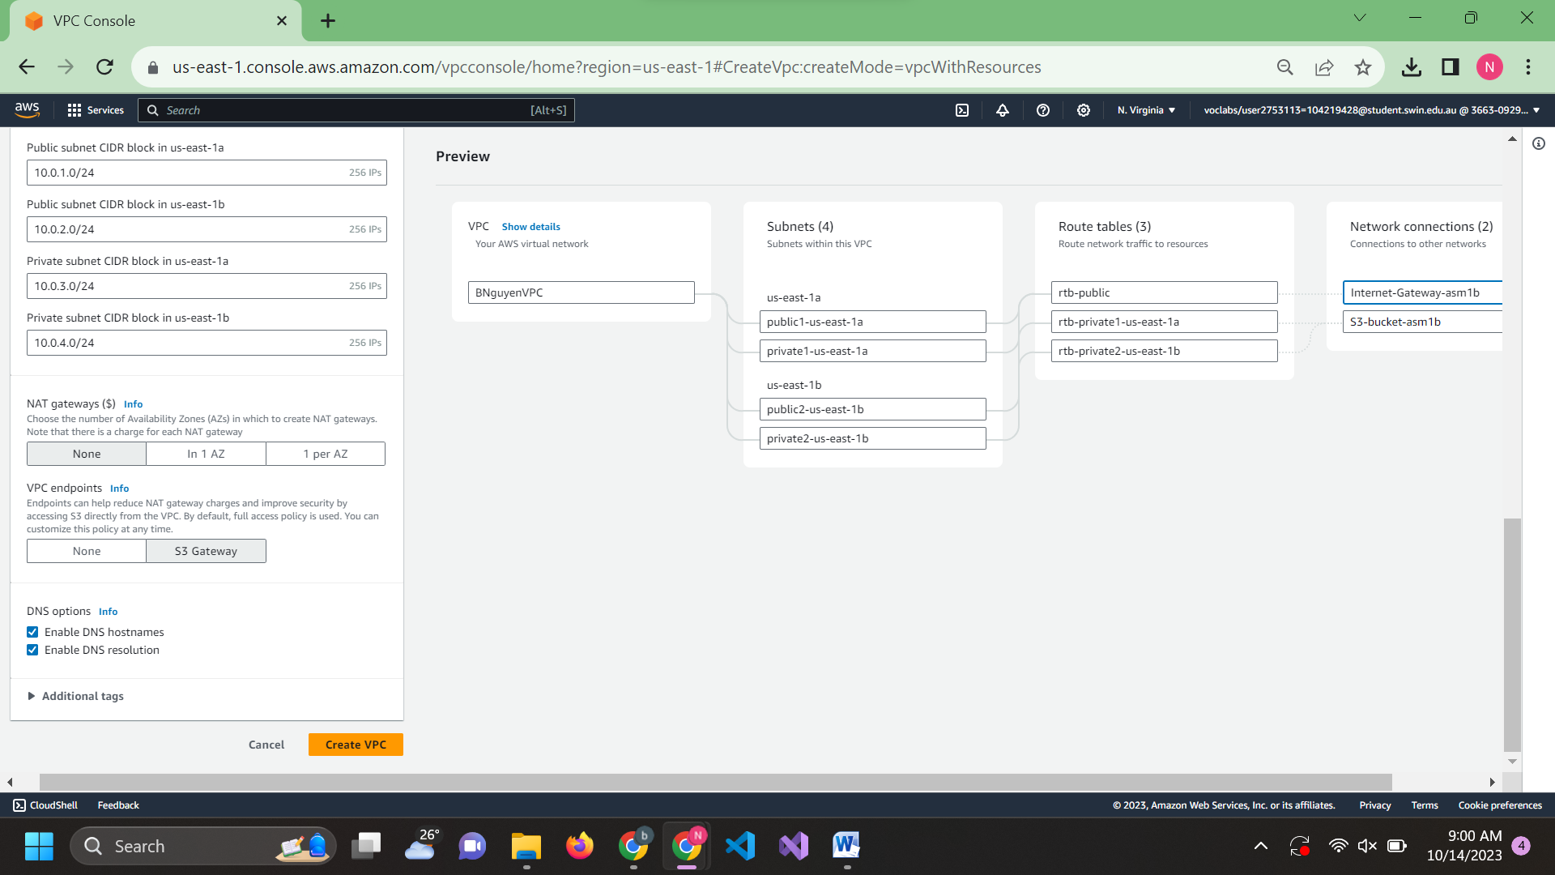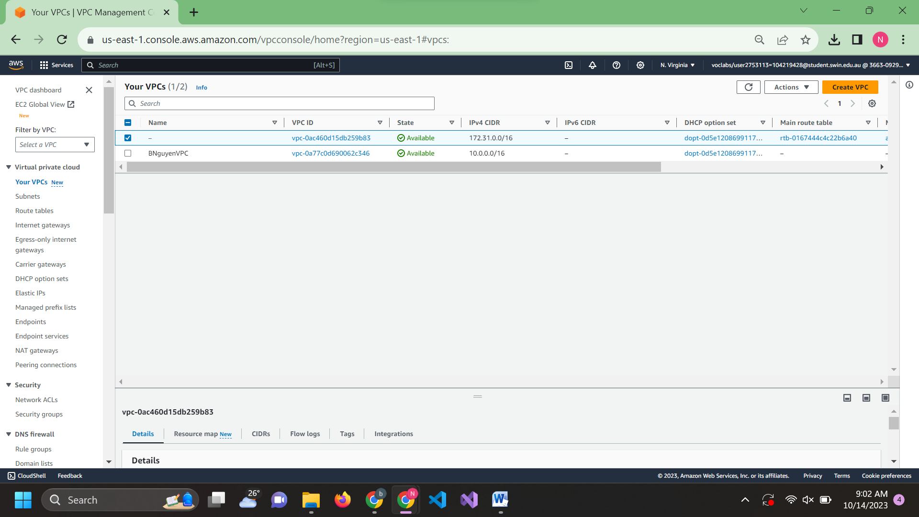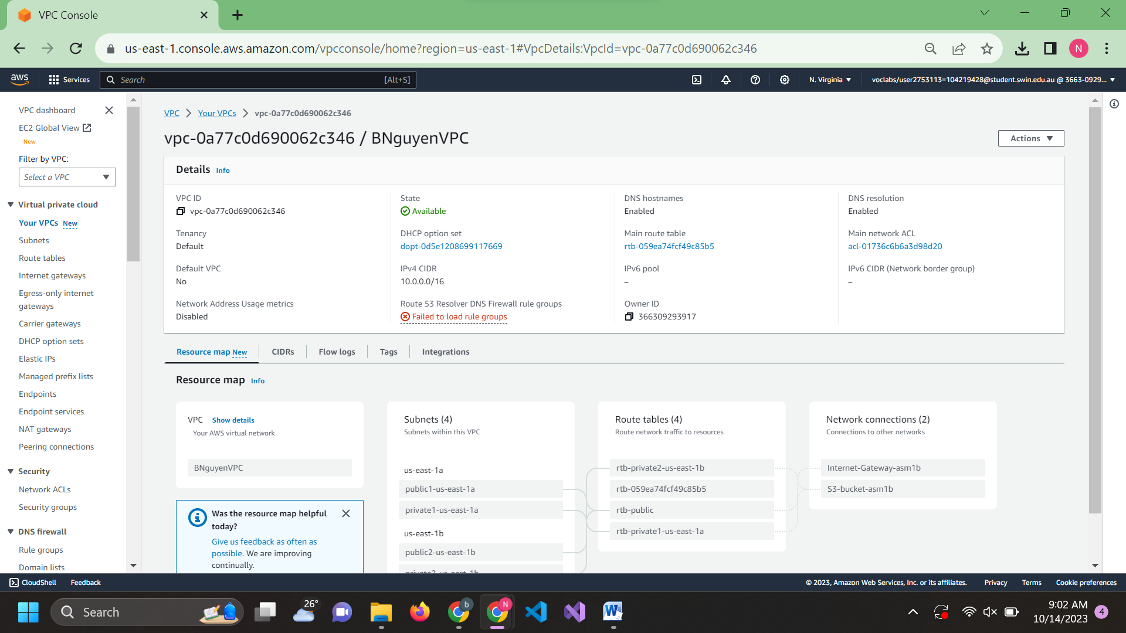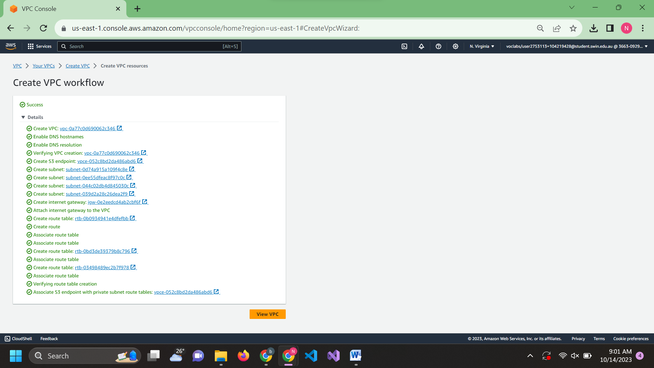

Step 3: Create security group. Access through the left navigation panel

3.1: TestInstanceSG

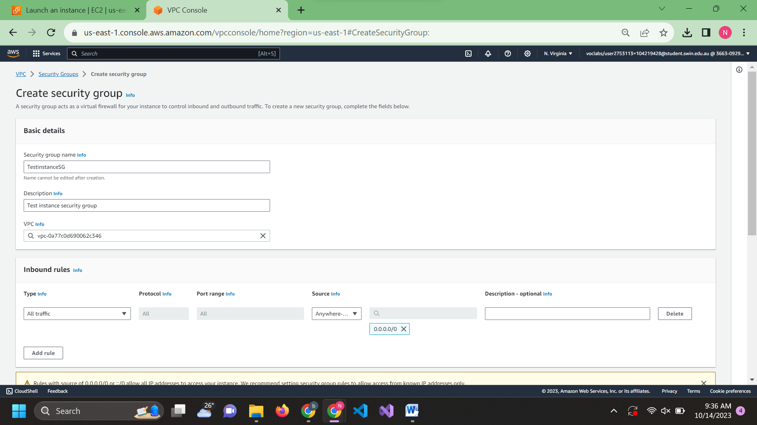

3.2:WebServerSG

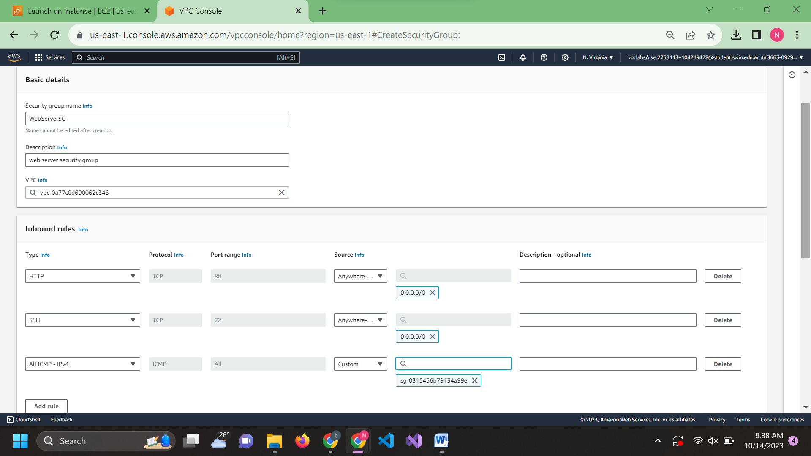

3.3:DBServerSG

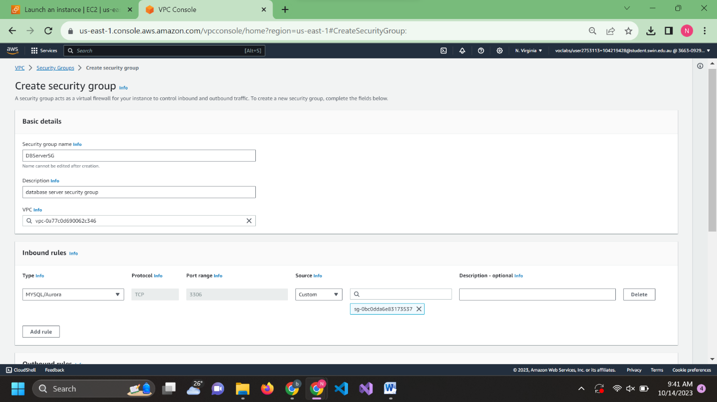

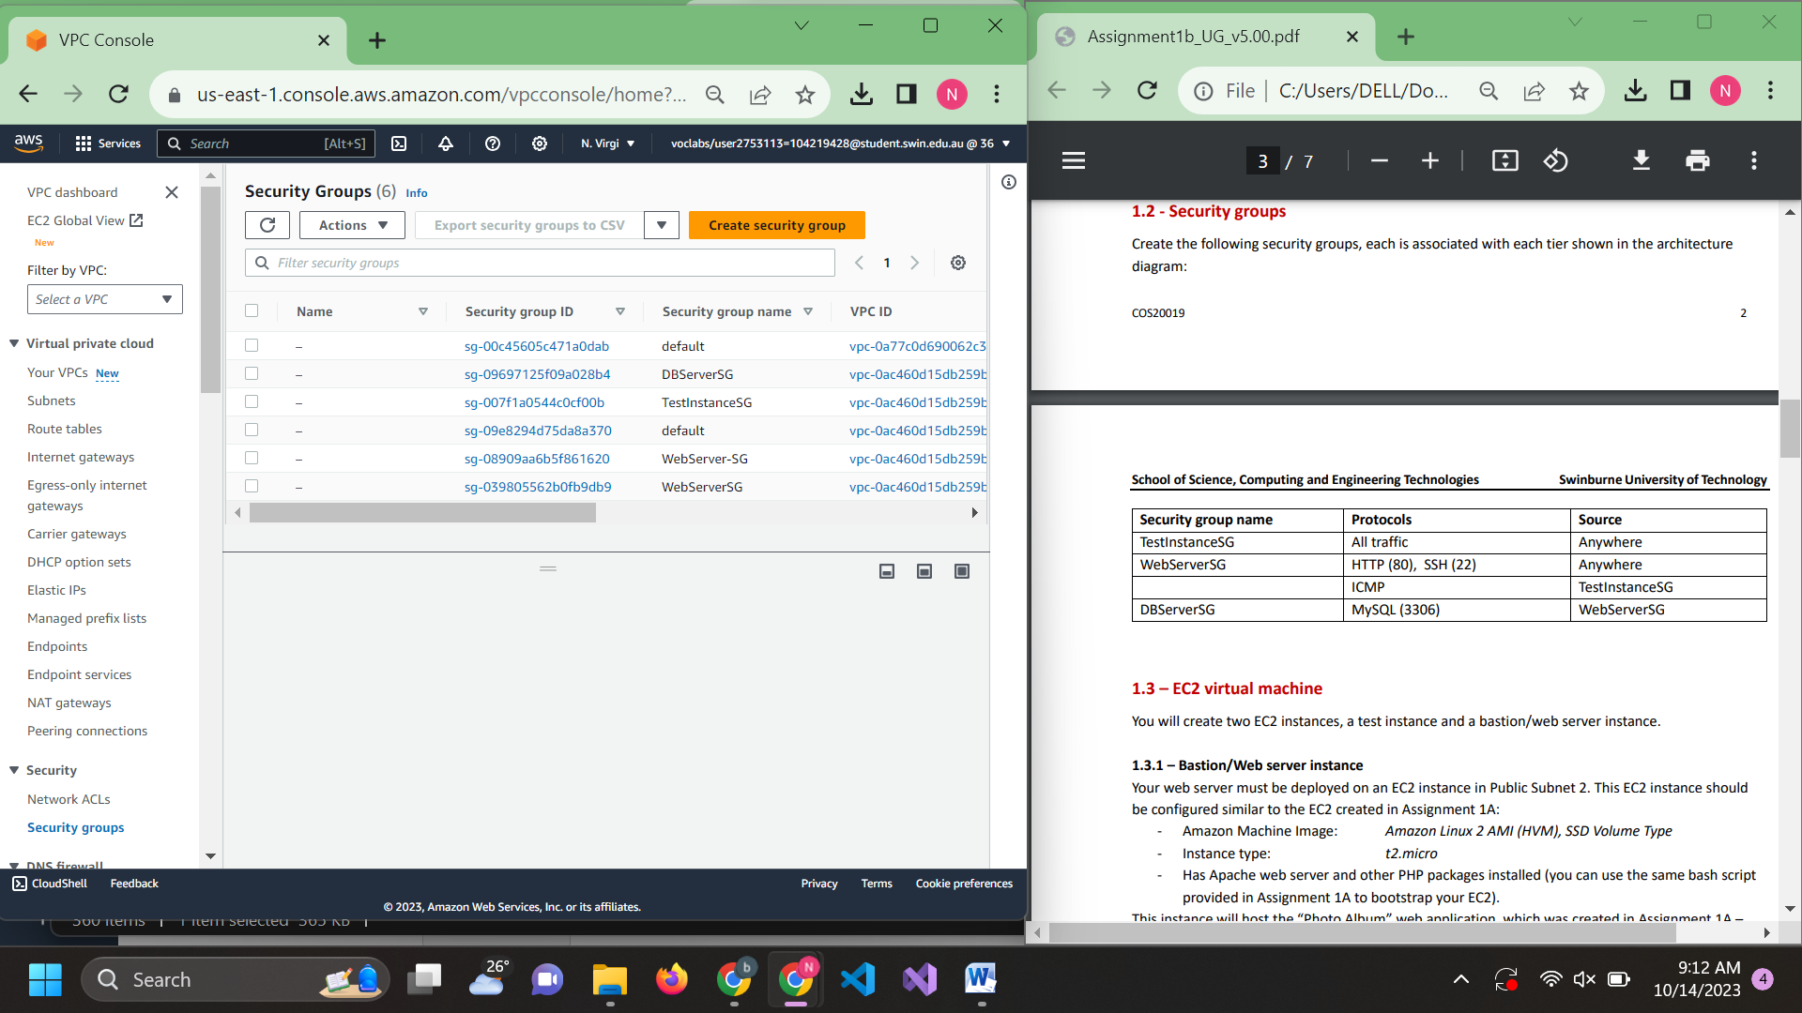

Step 4: Create 2 EC2 instance

4.1: Bastion/Web server EC2

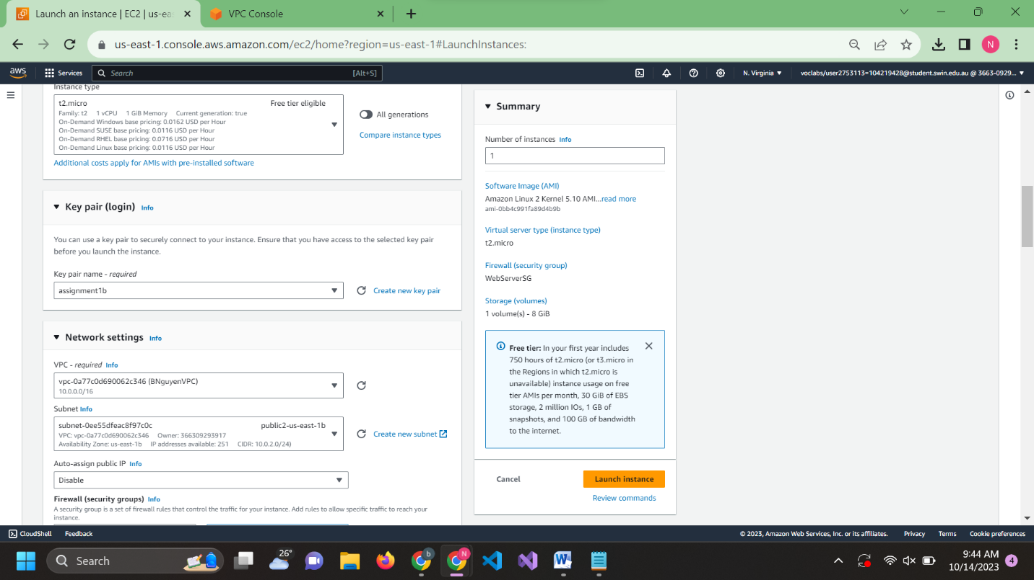

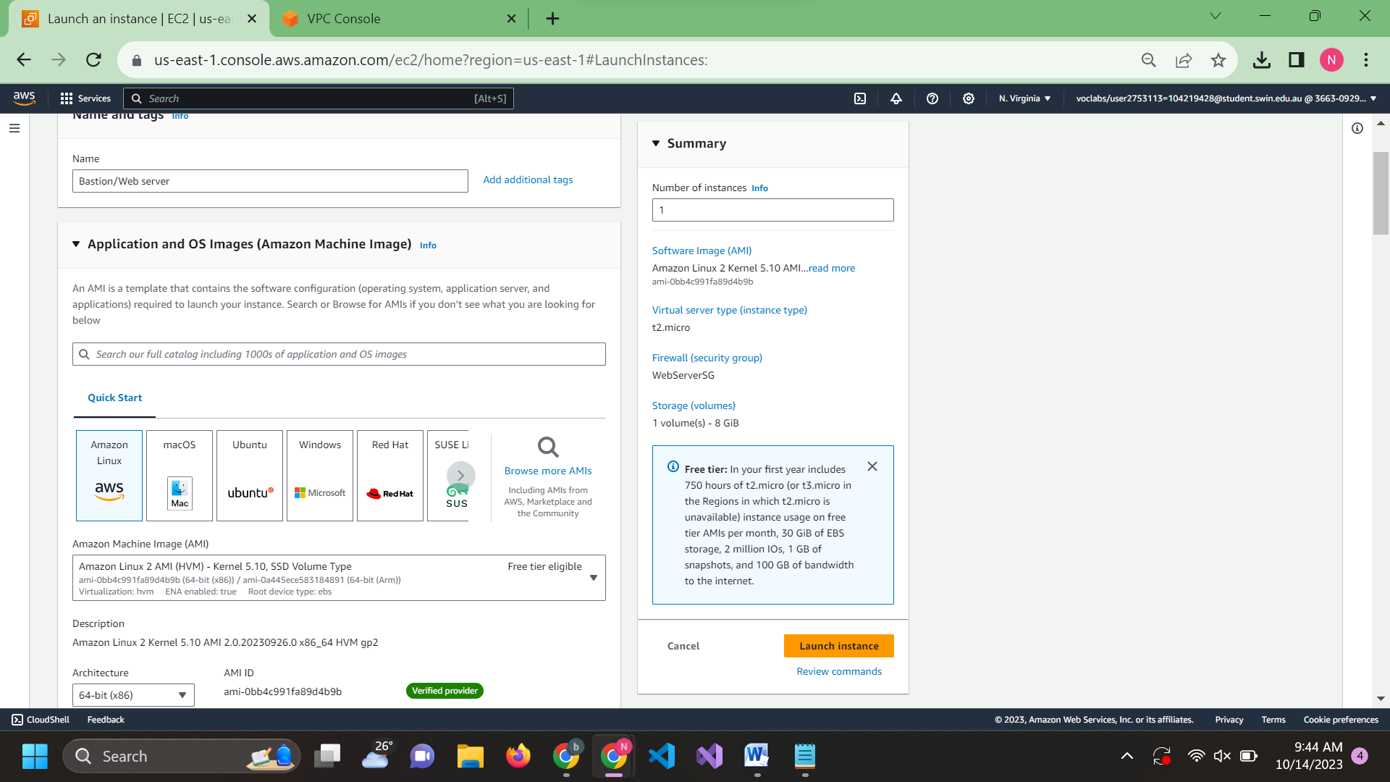

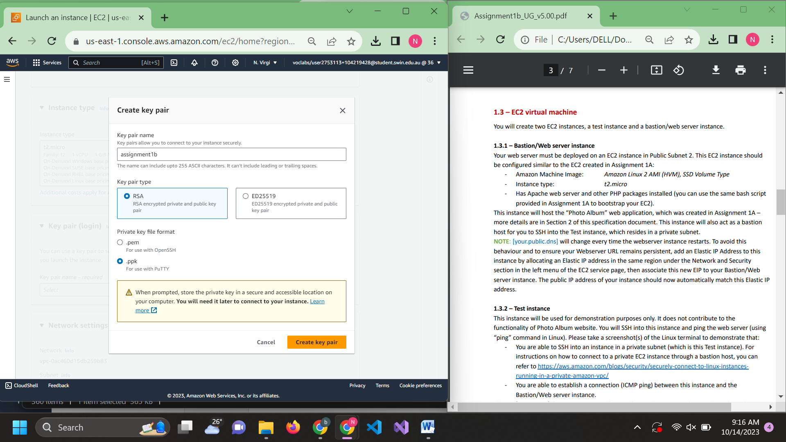

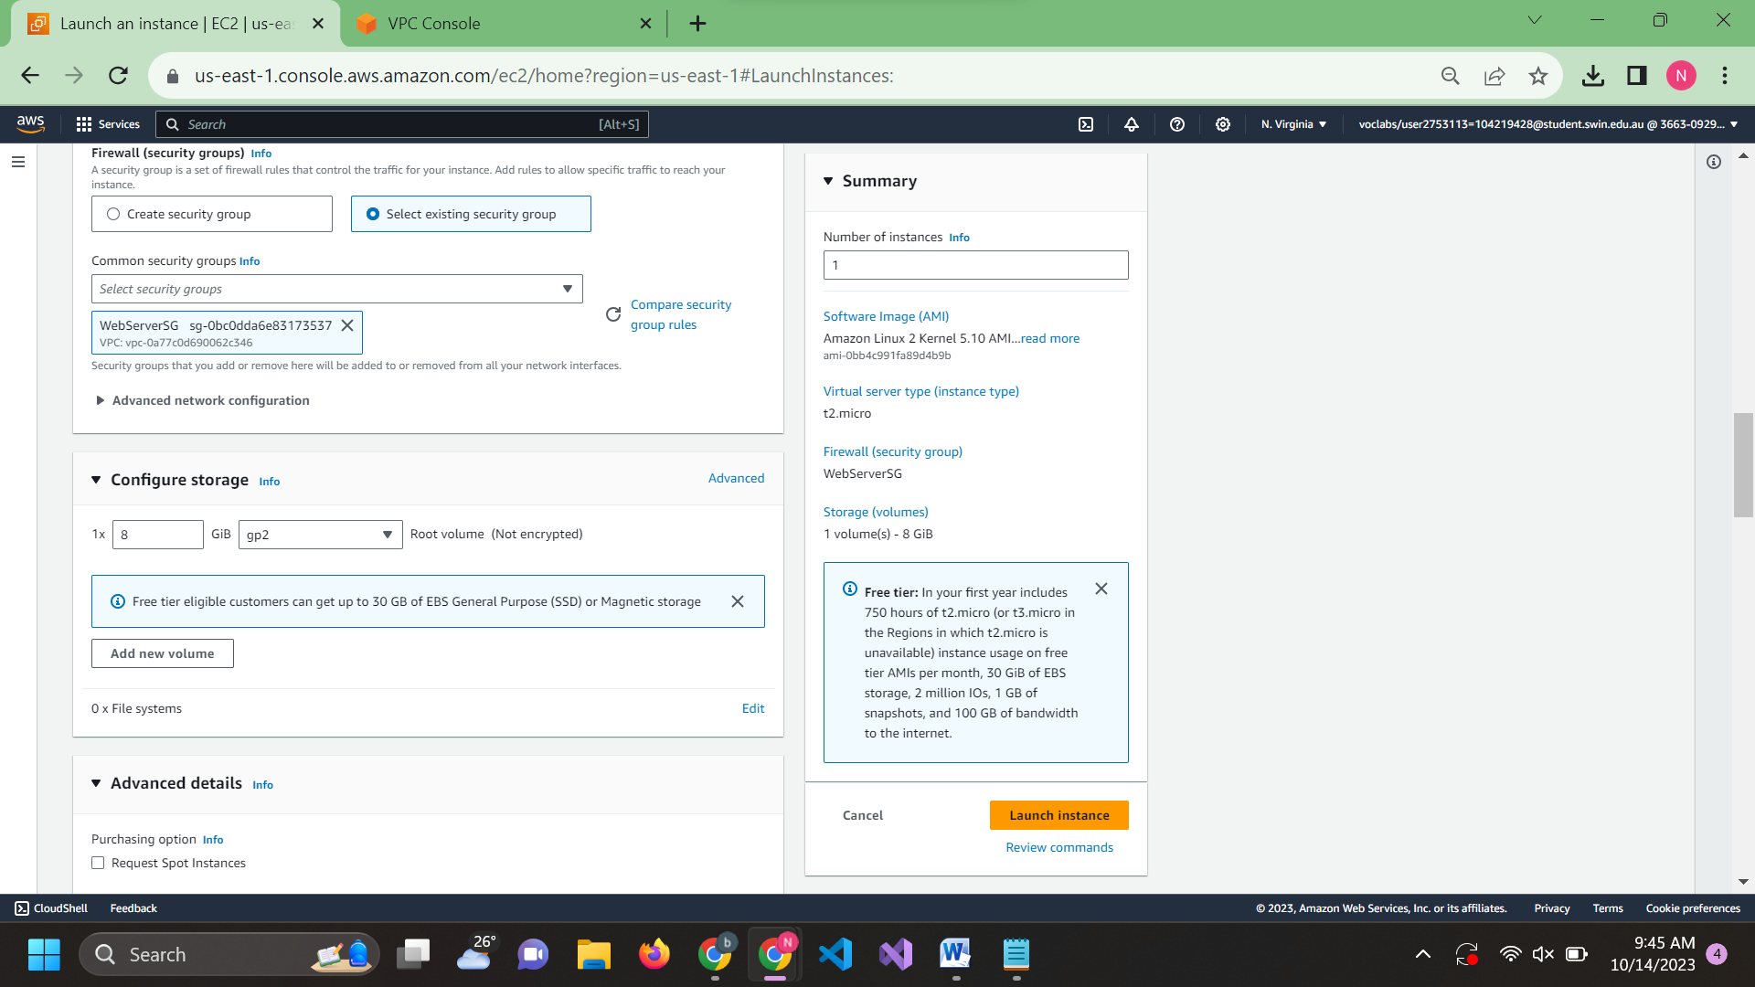

Reuse the script from asm1a to setup

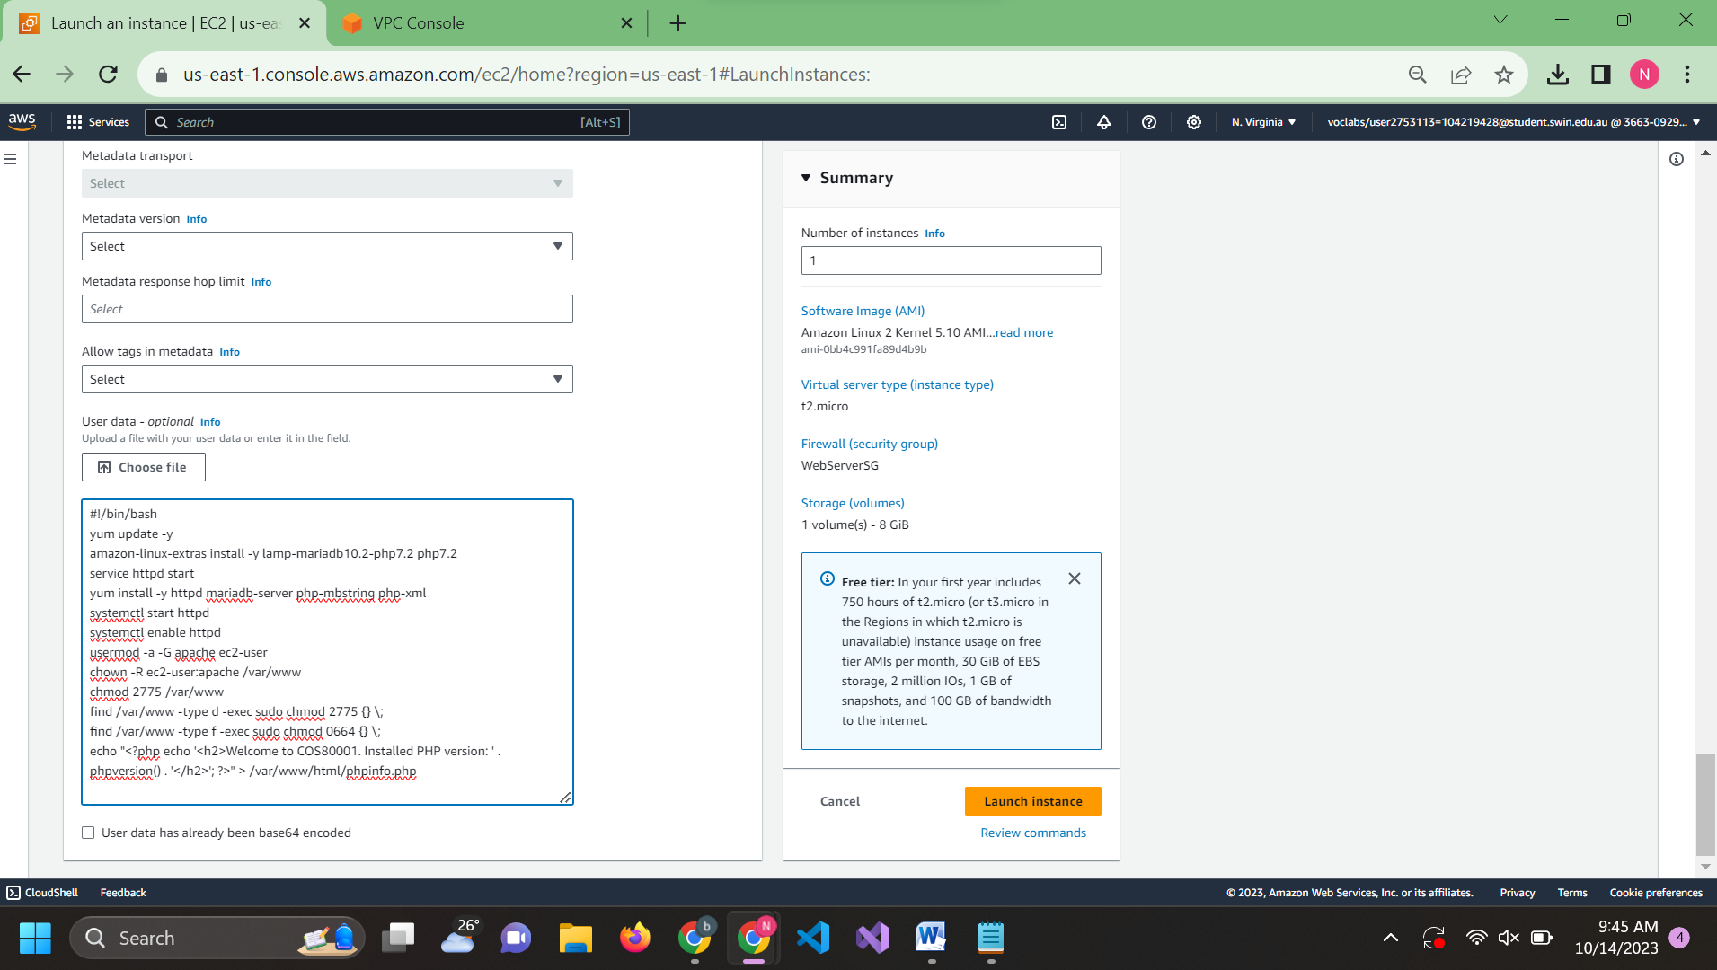

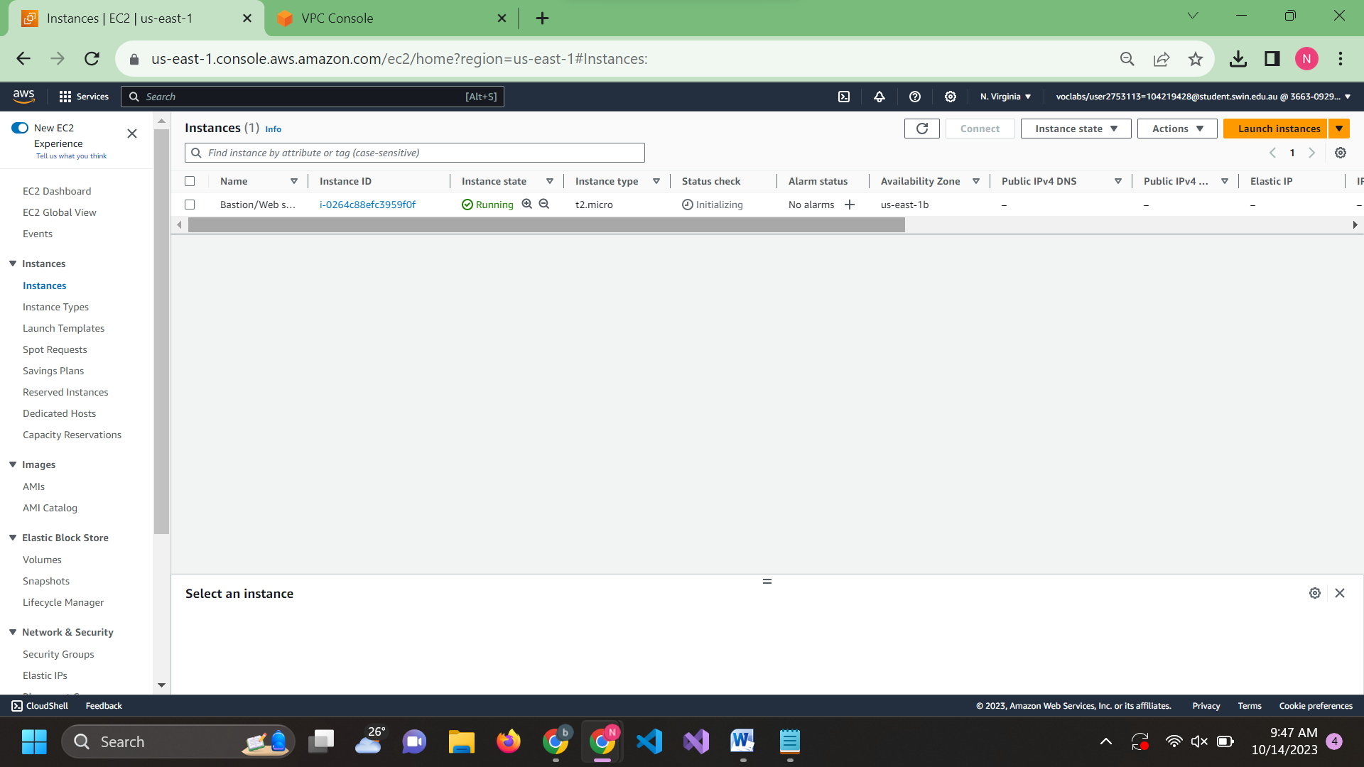

Open left navigation panel and choose Elastic IP Address and choose Allocate Elastic IP Address

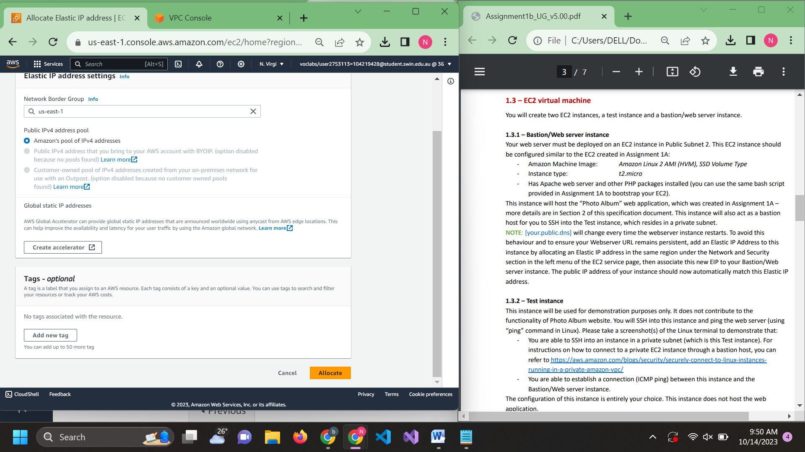

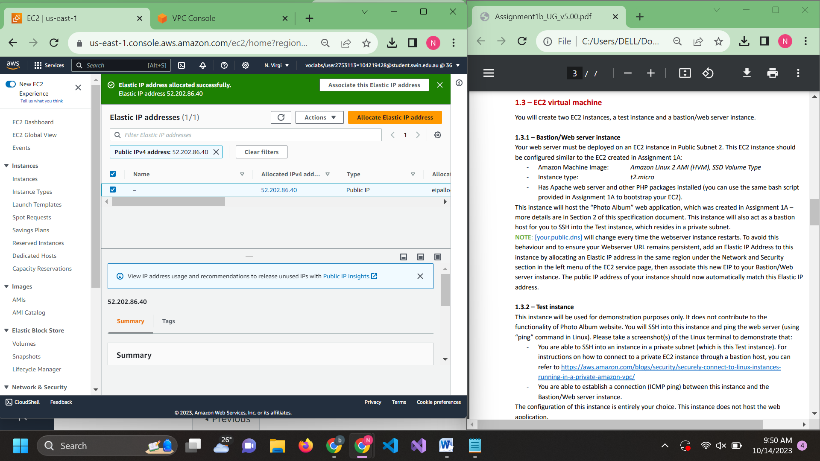

Select the created elastic IP and choose Action -> Allocate Elastic IP Address and add the Bastion/… EC2 instance to it

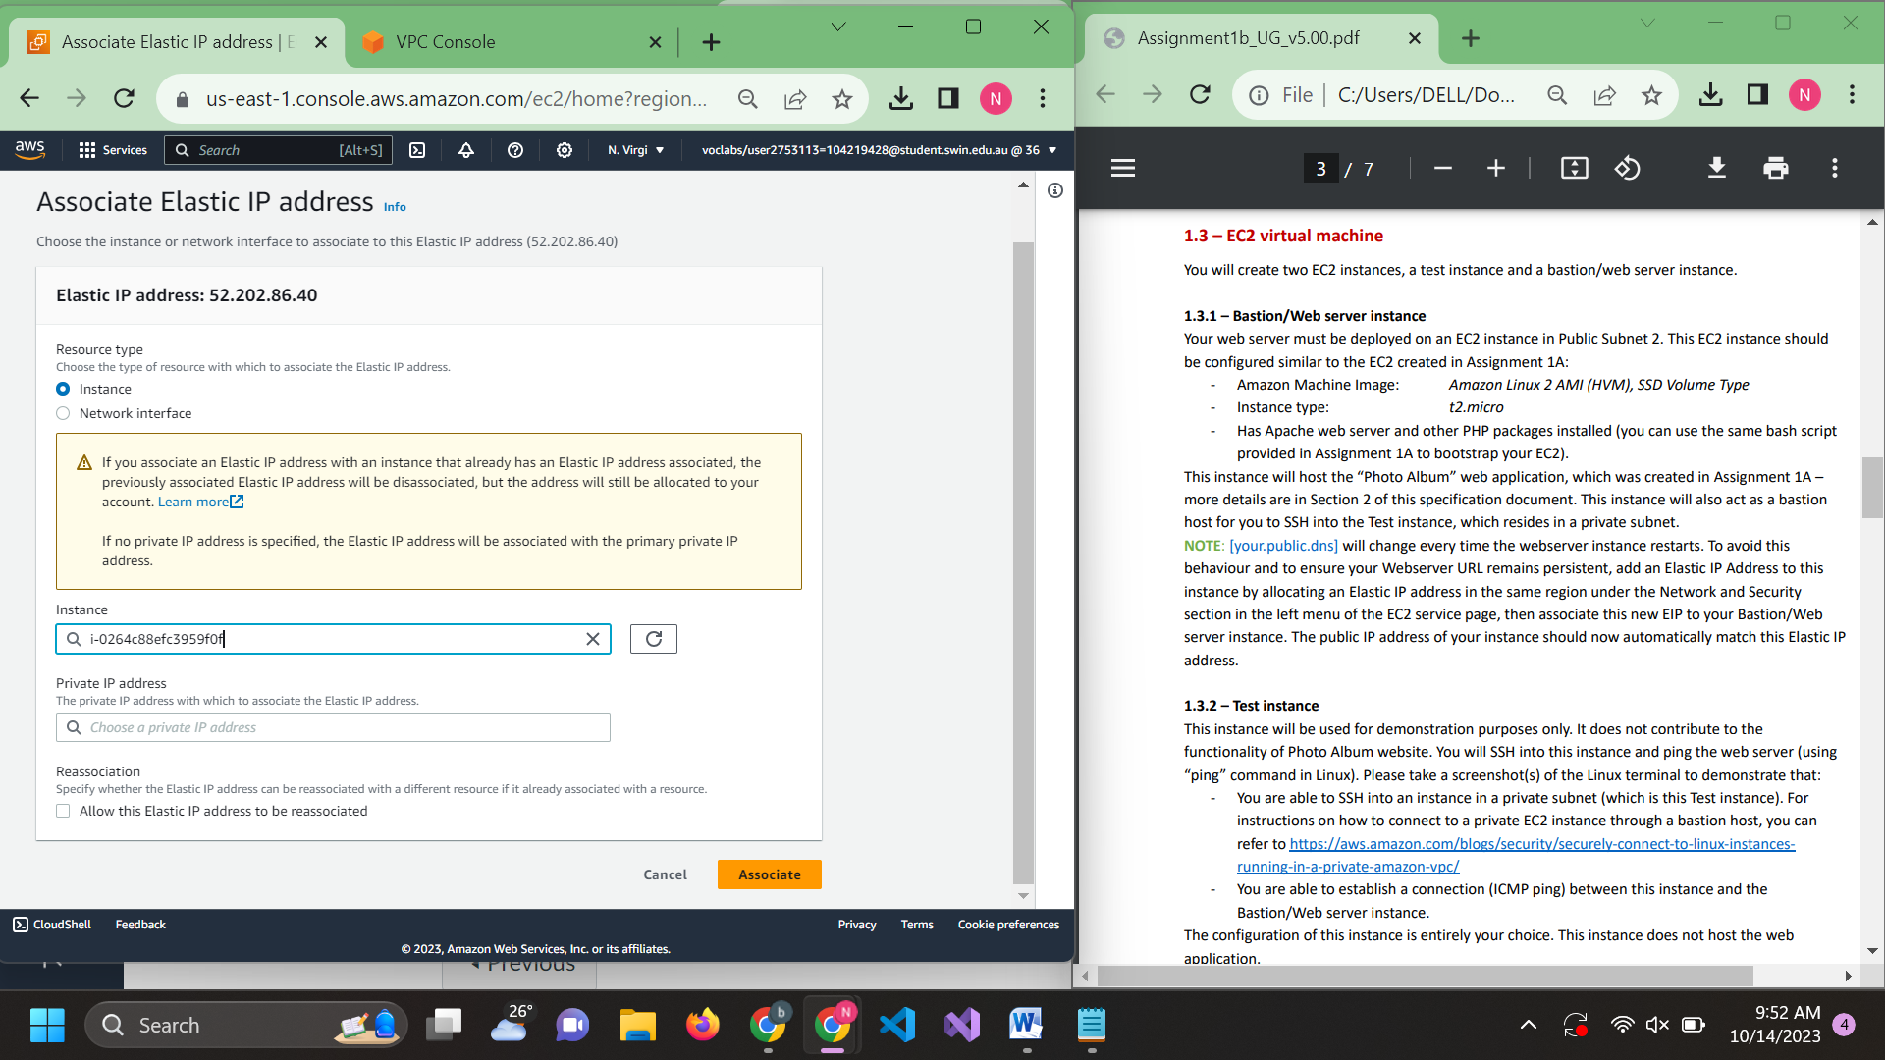

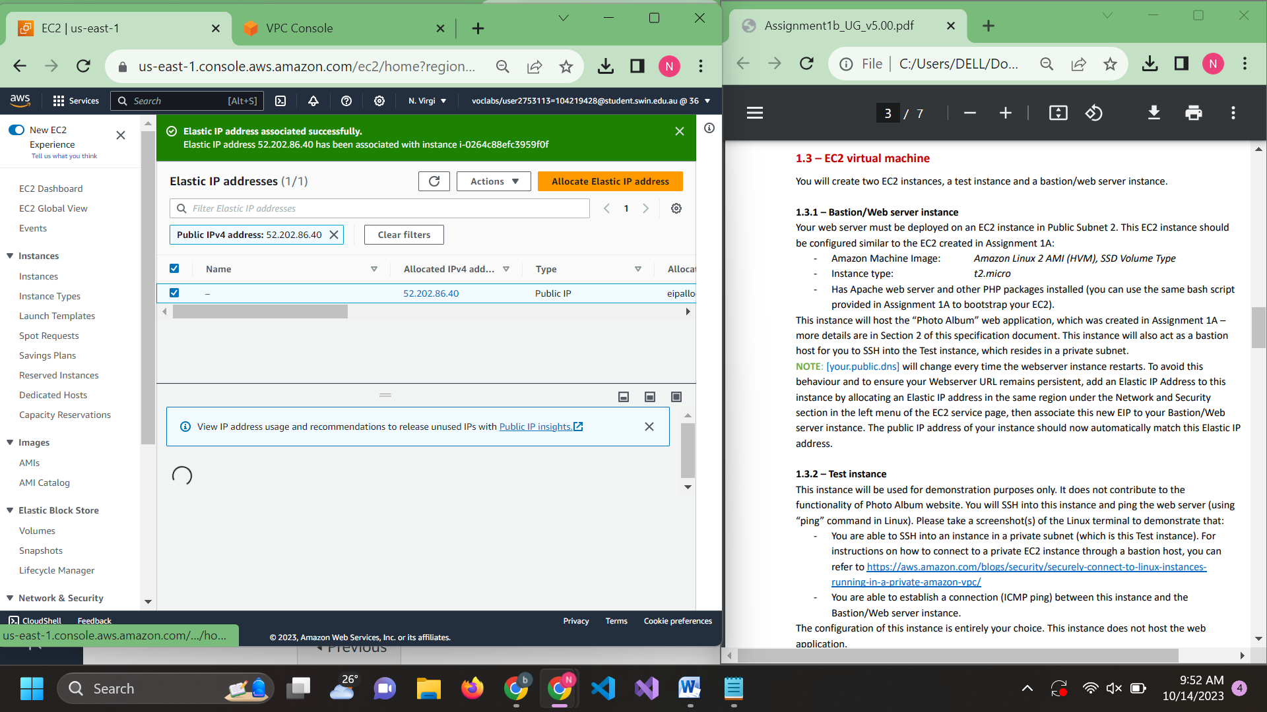

4.2: Test instance. Since it is not specified how this is config I left it the same as Bastion but different security group and no script

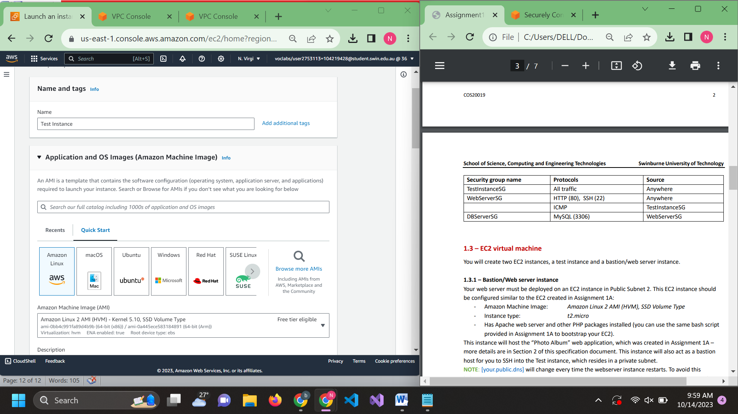

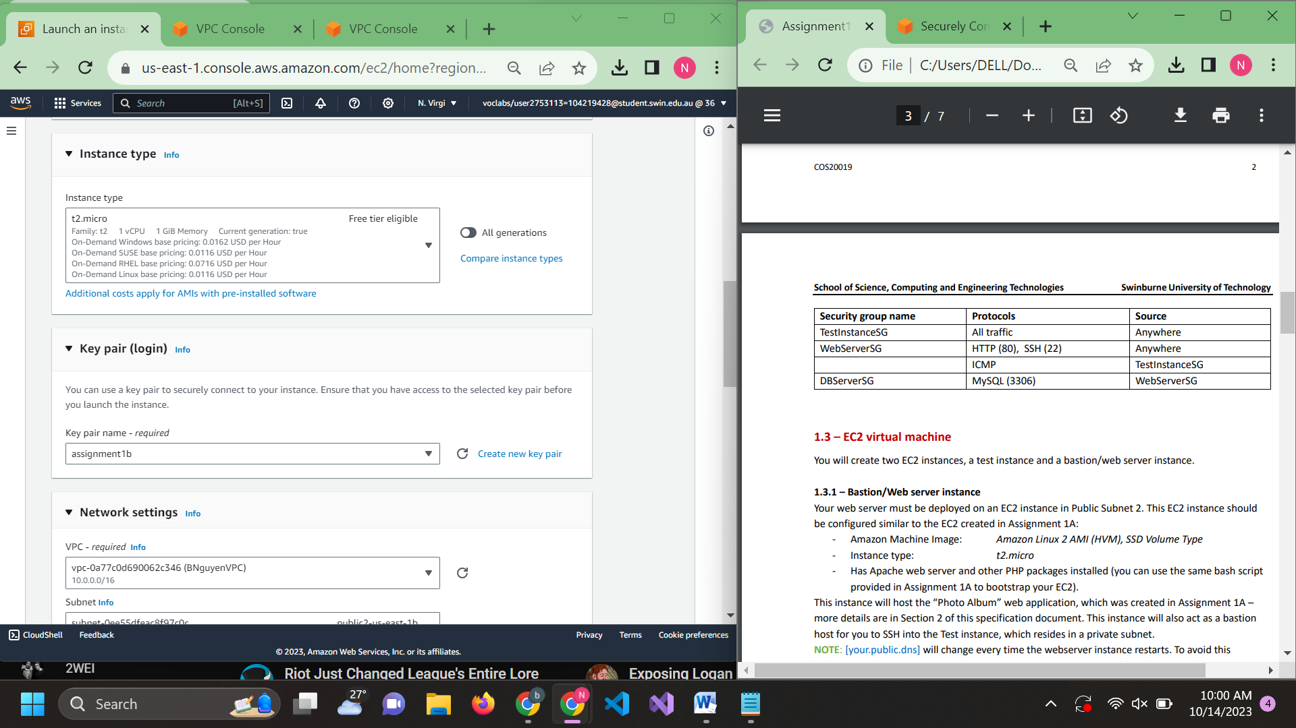

I Config-ed the subnet wrong so I have to comeback and config it again with the right private subnet but forgot to take the screenshot

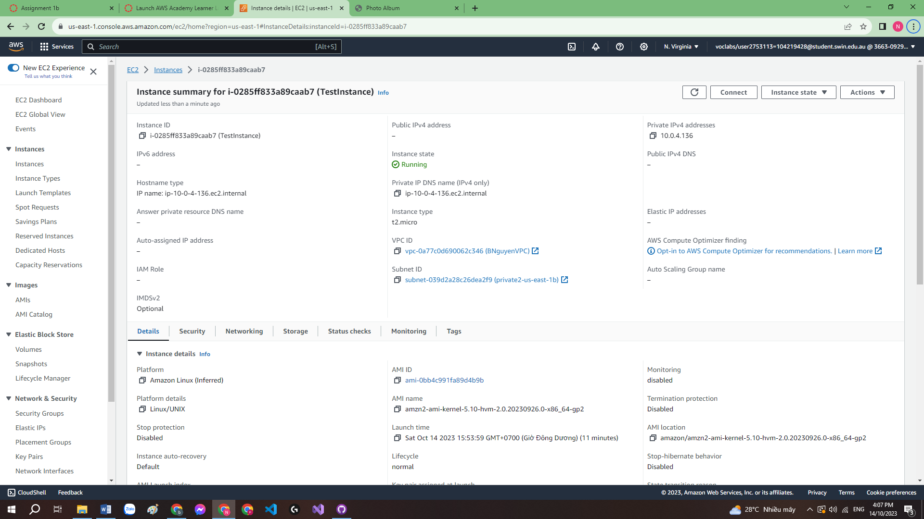

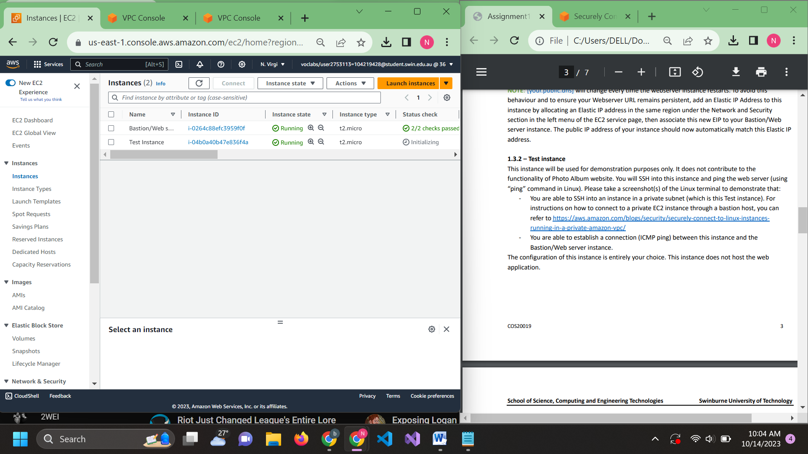

4.2.2: Test it using putty

Copy Bastion public IPV4 and use it as hostname

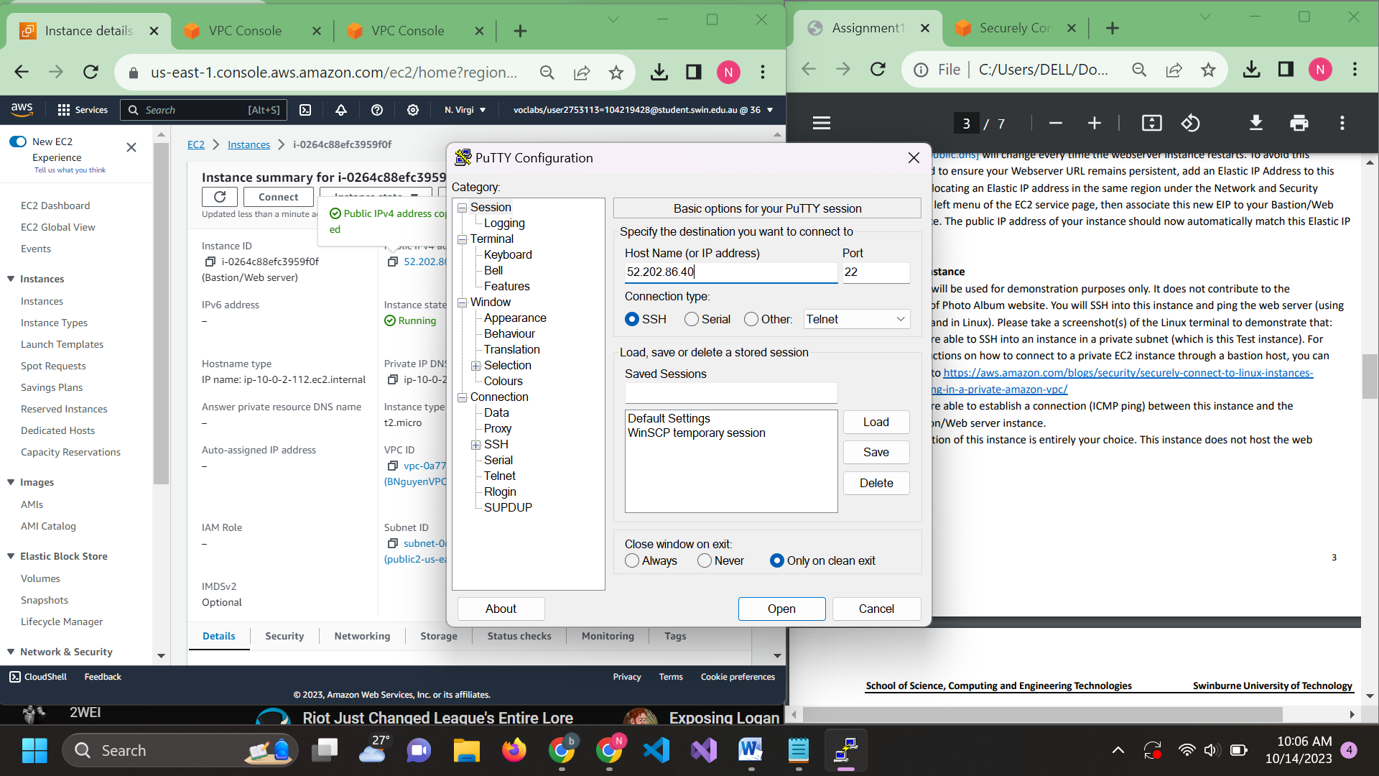

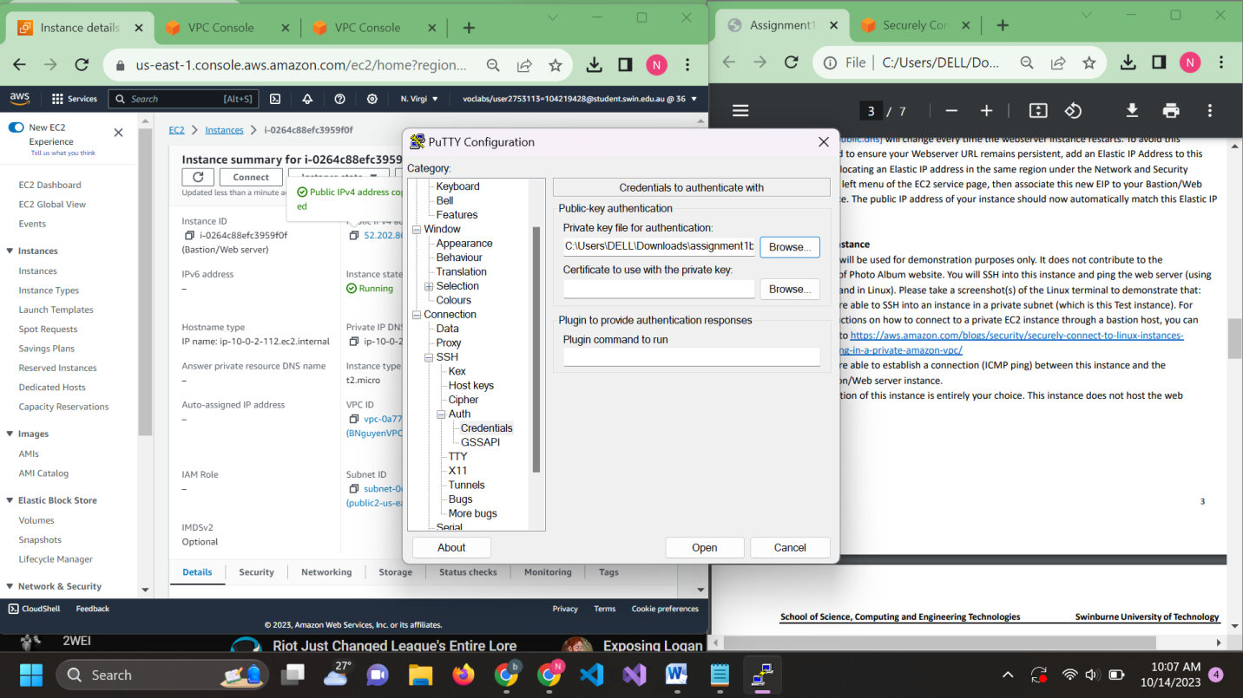Use the keypair u created when creating Bastion

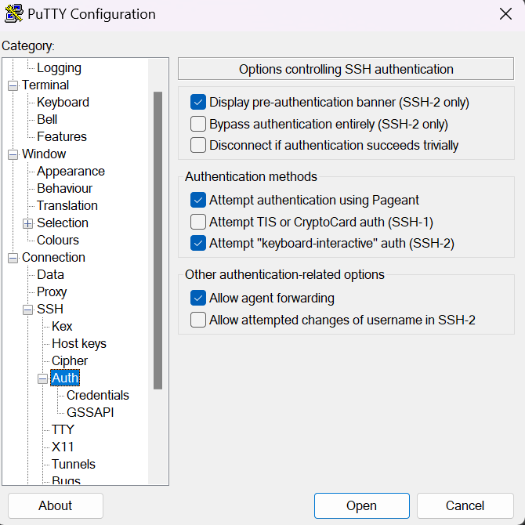

Accept

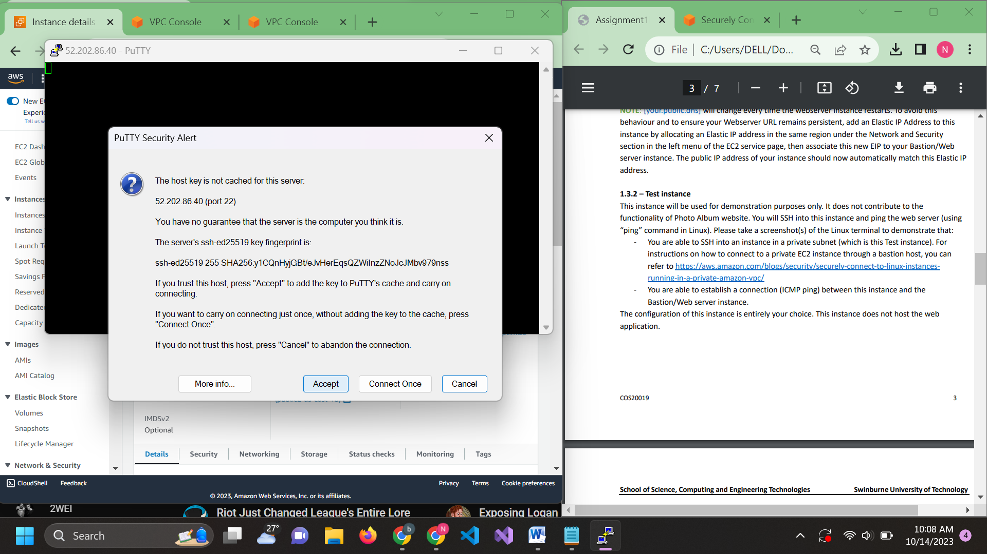

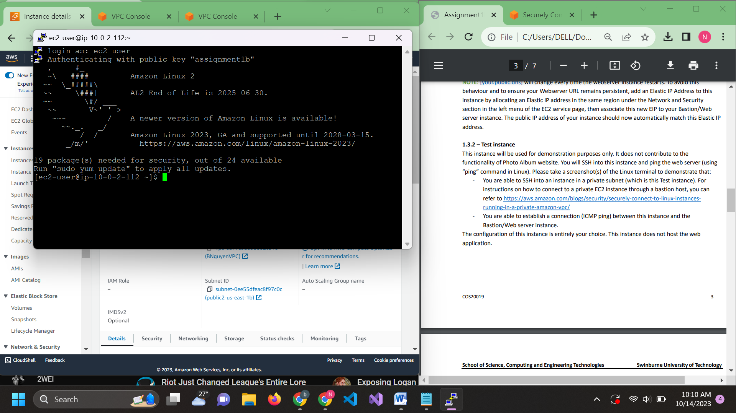

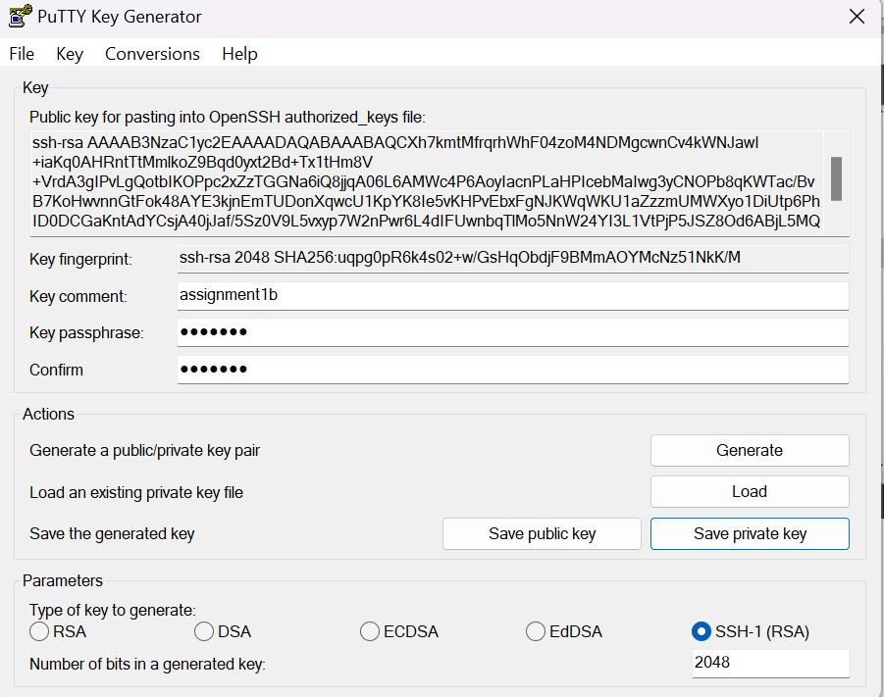Go into puttyGen convert the created key

Go into putty and enter ssh ec2-user@10.0.4.14 (10.0.4.14 is the Test instance private ipv4)

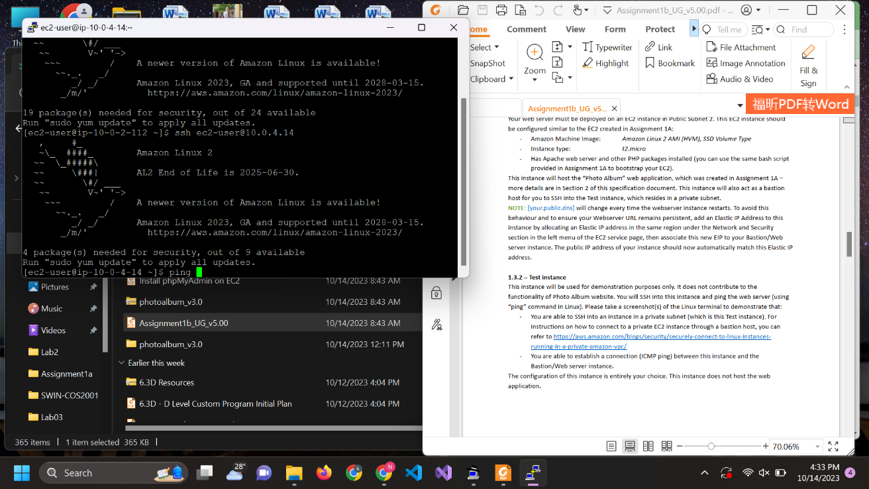

Ping Bastion using it private IPv4

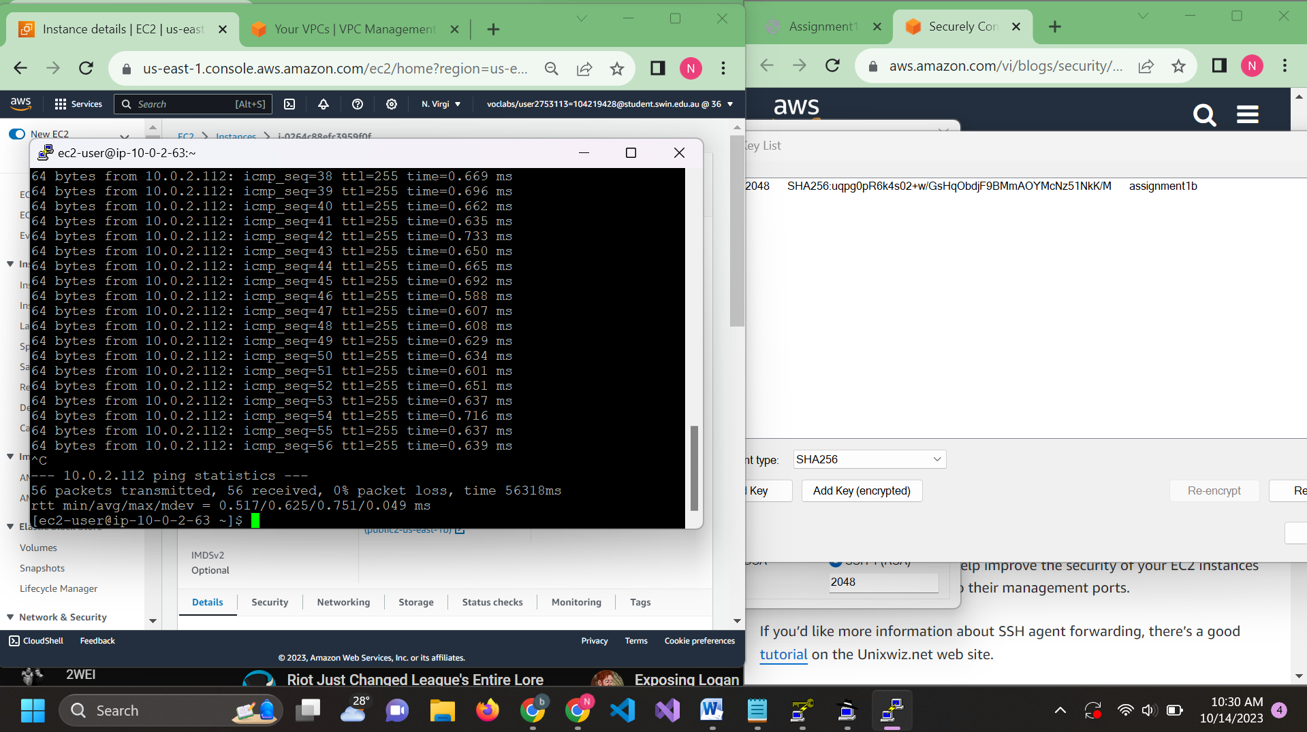

Step 5: crate RDS database instance

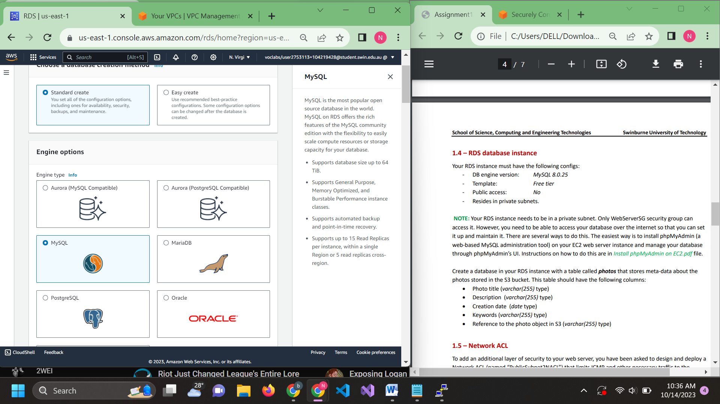

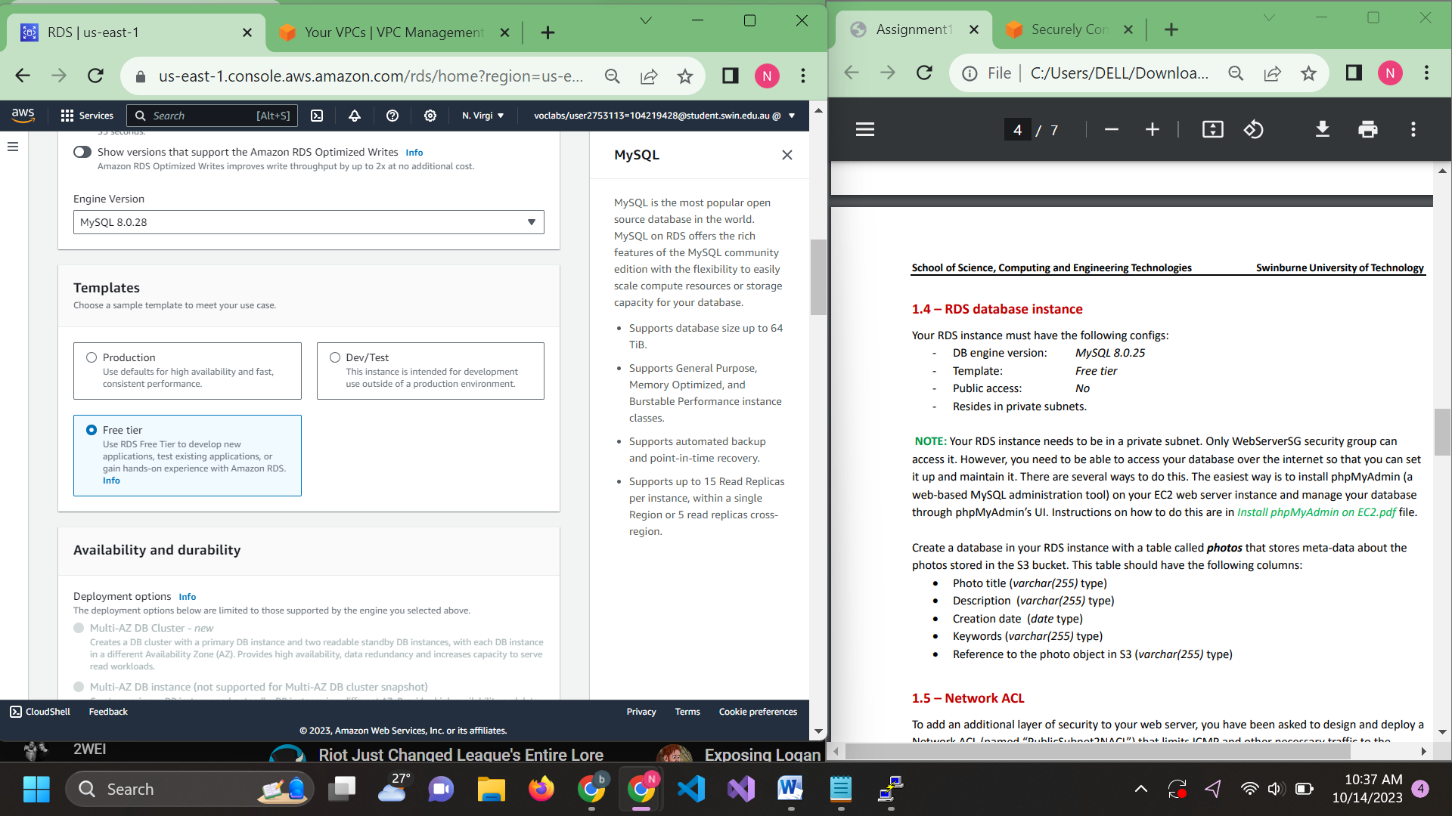

User: admin

Password: lickmya707

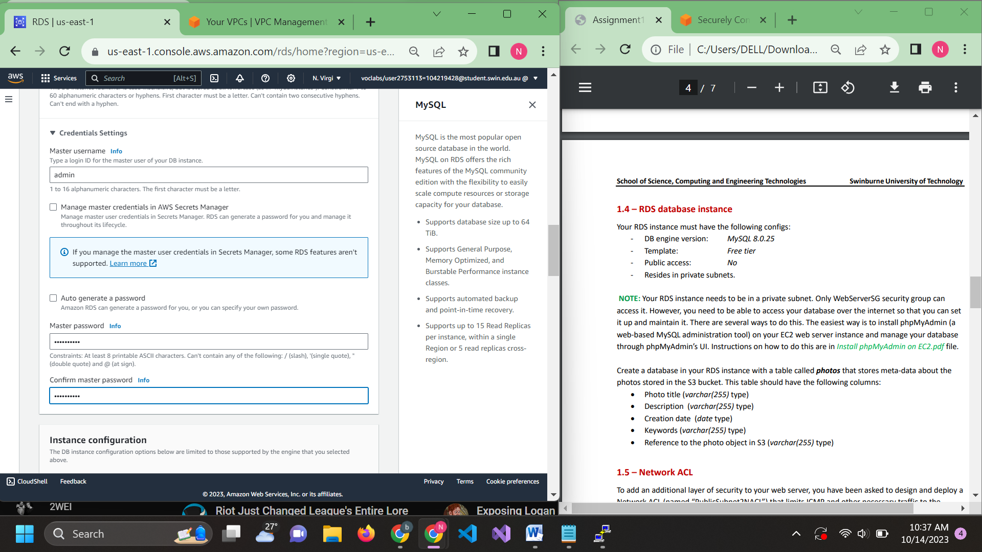

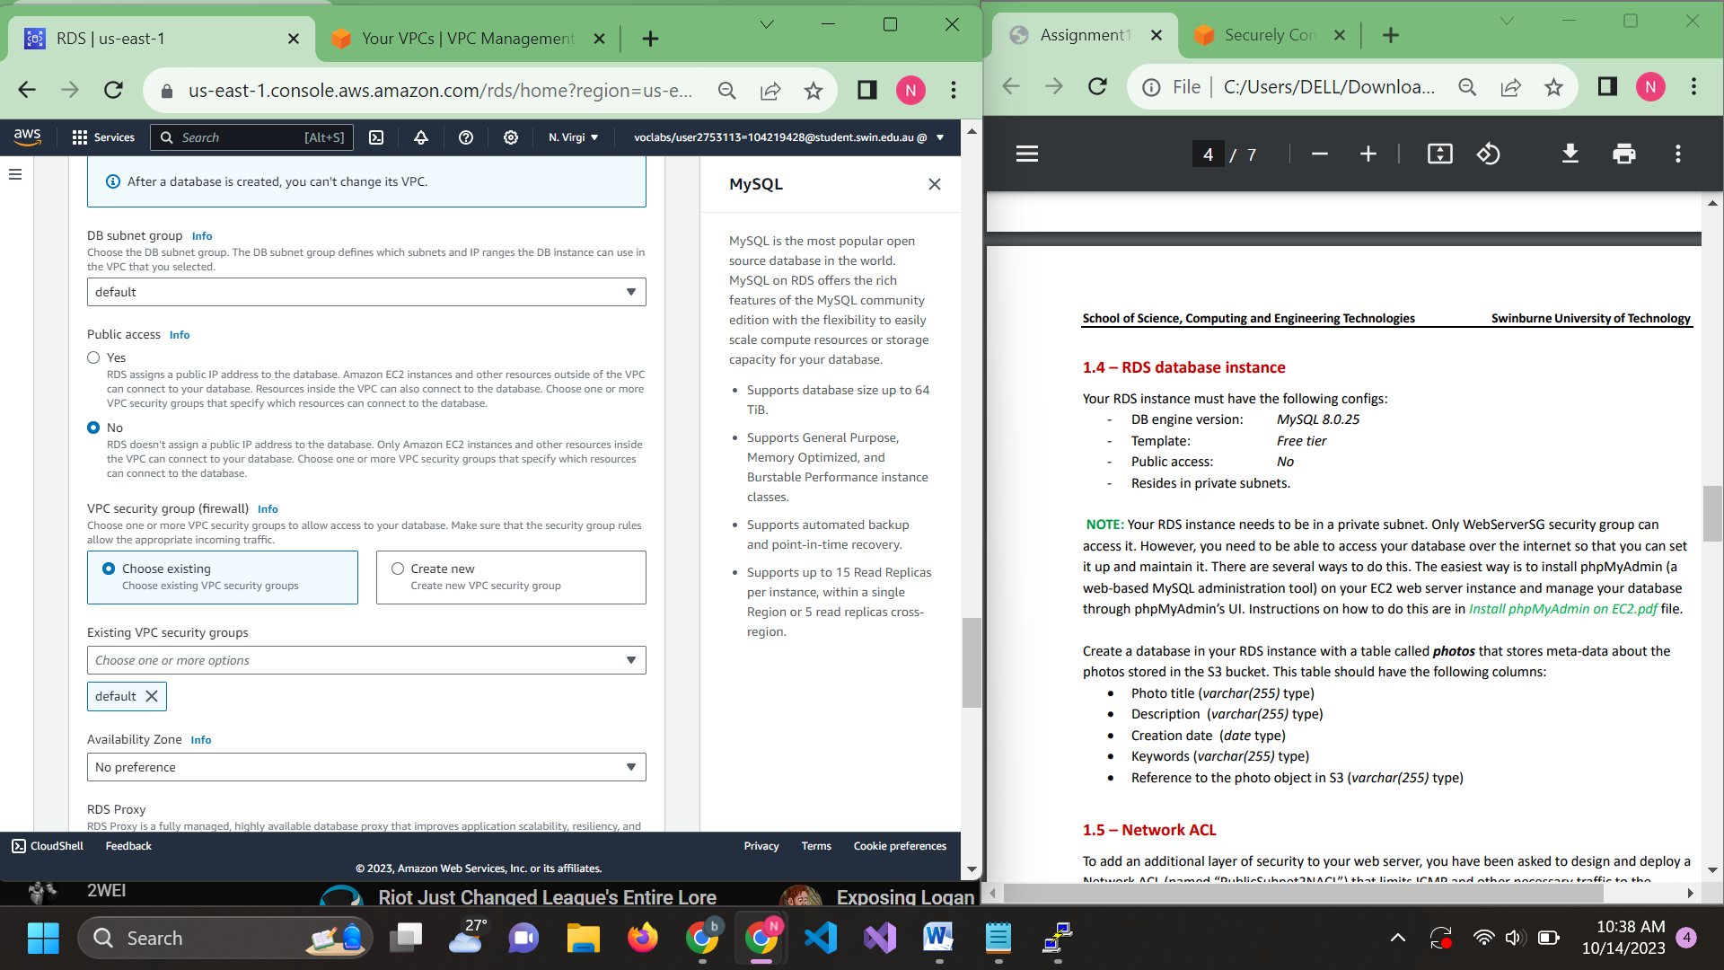

So I forgot to config subnet and put it in the database so let create the subnet group first

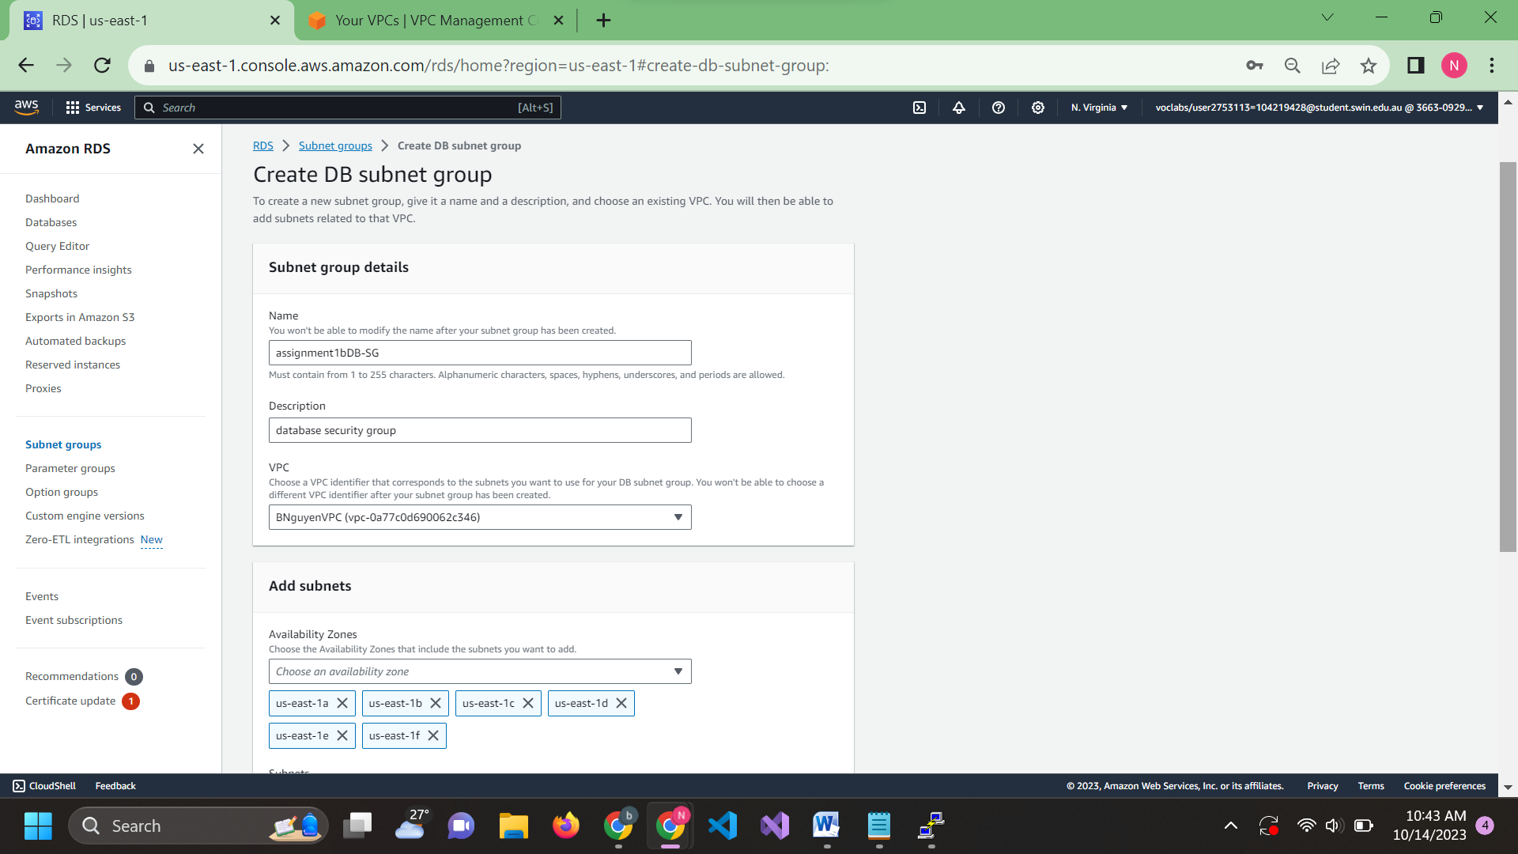

Select all the correspond private subnet

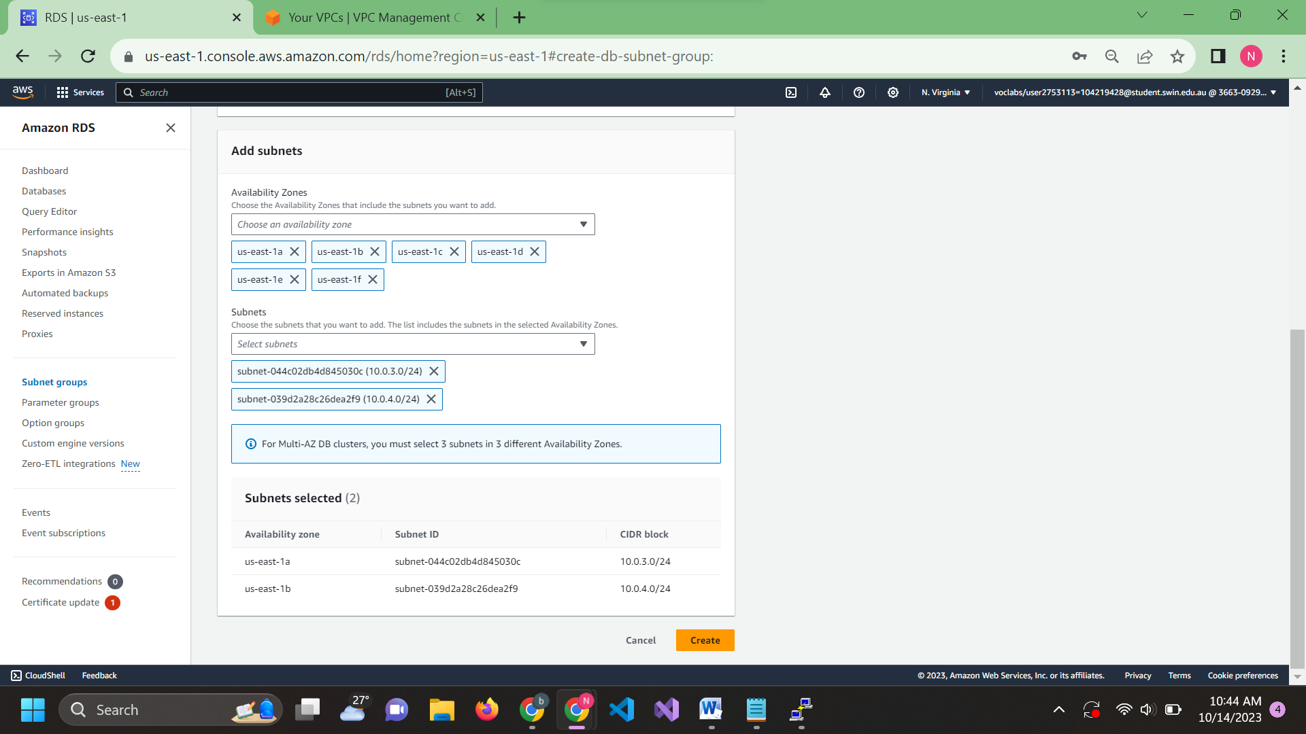

Config the database again but change the connectivity section

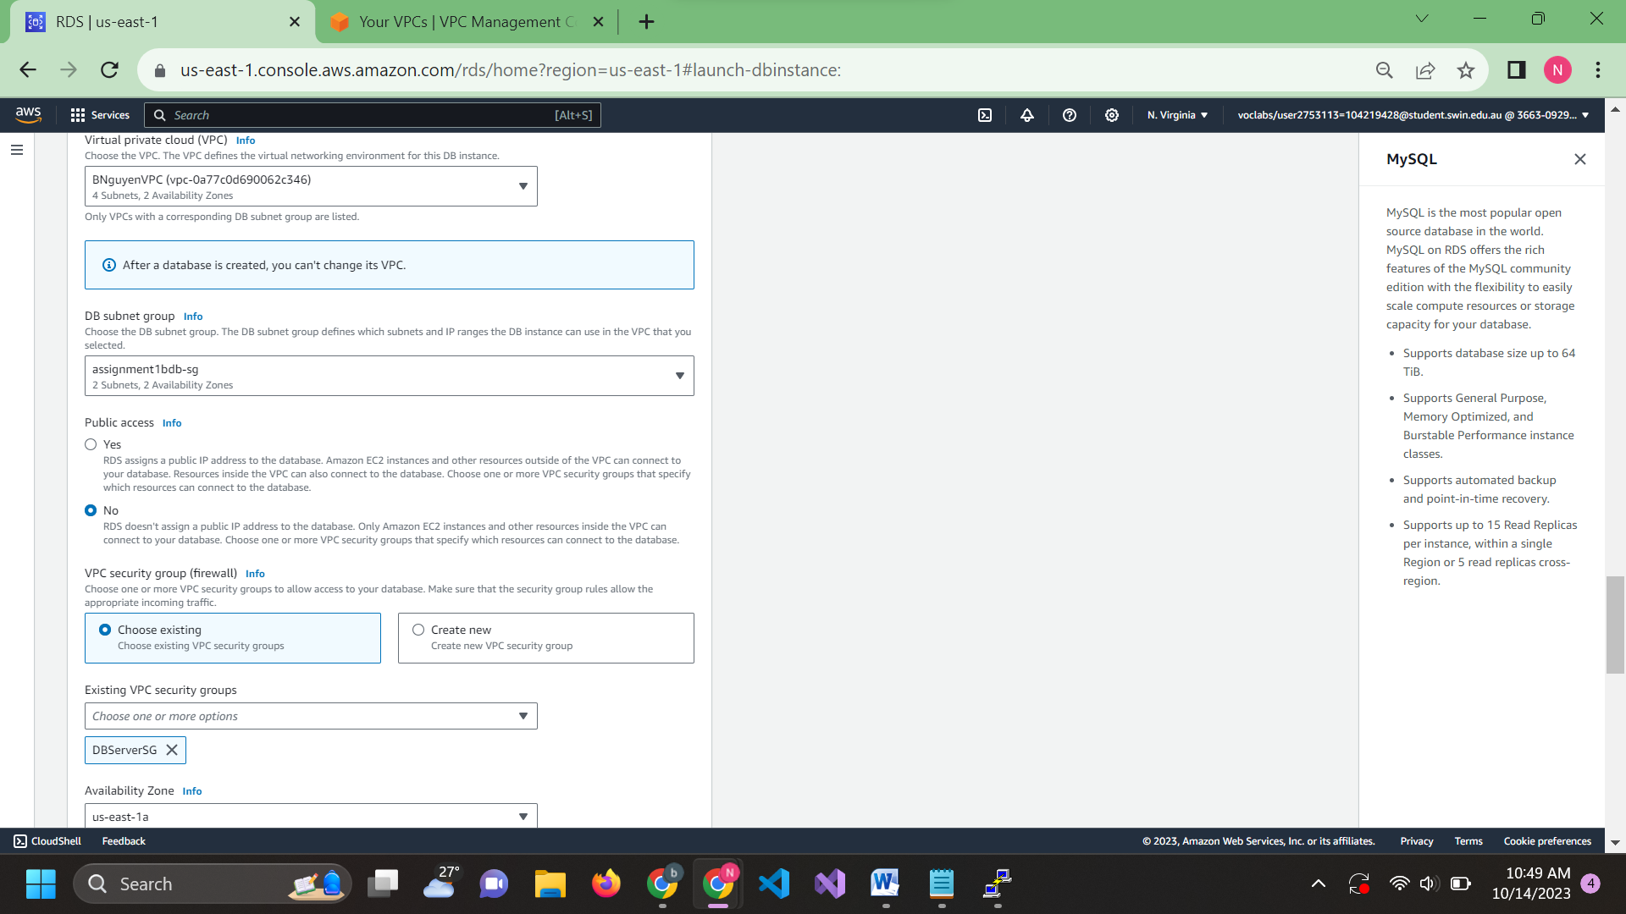

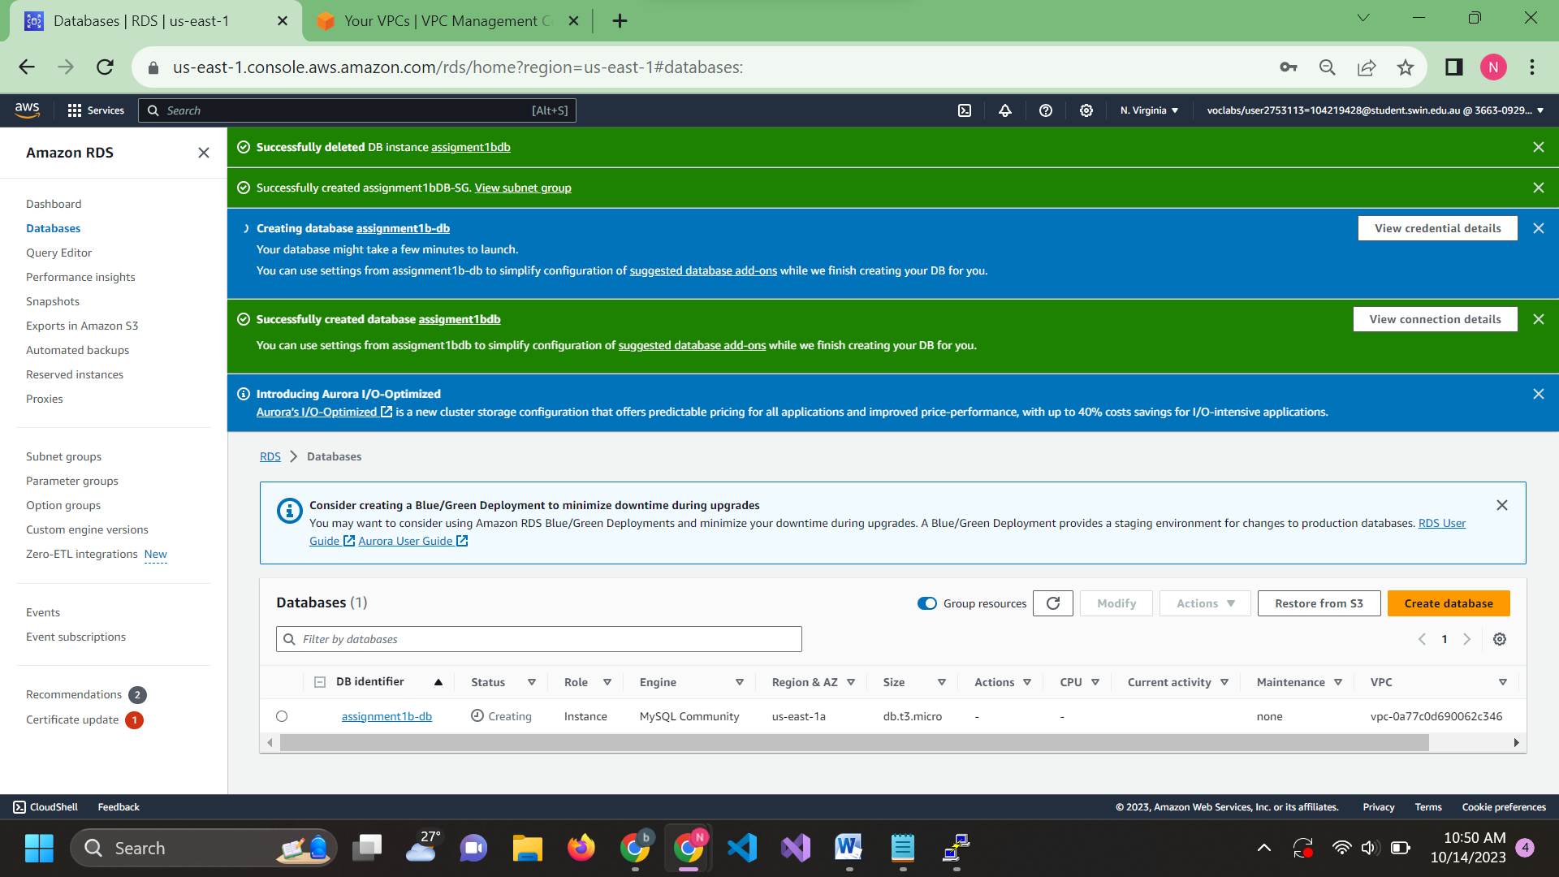

Access Putty again this time use Bastion public ipv4

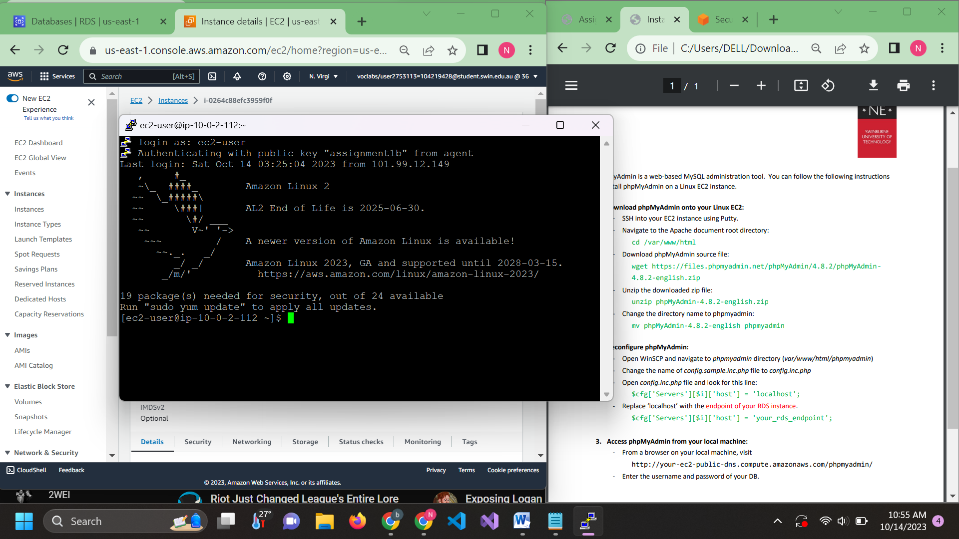

To fix this u need to copy the directory from the pdf into a text editor so the “-“ is not missing(I forgot to take the screenshot of that)

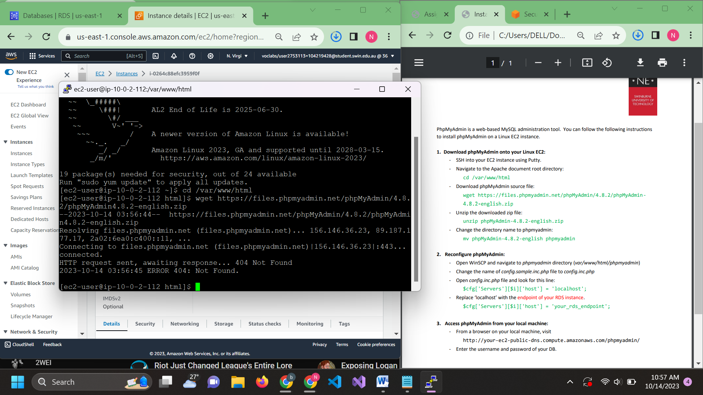

Unzip the file 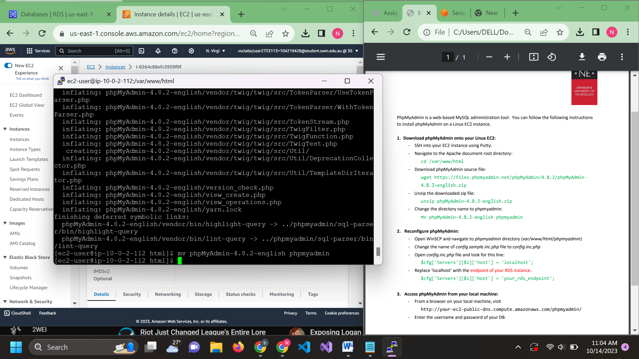

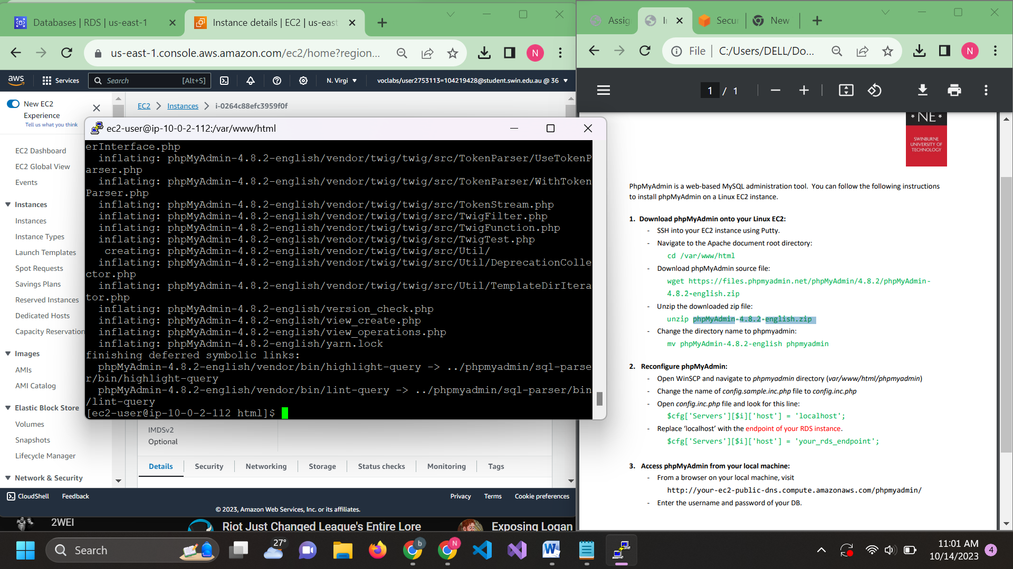

Go into WinSCP to access the Bastion using public DNS

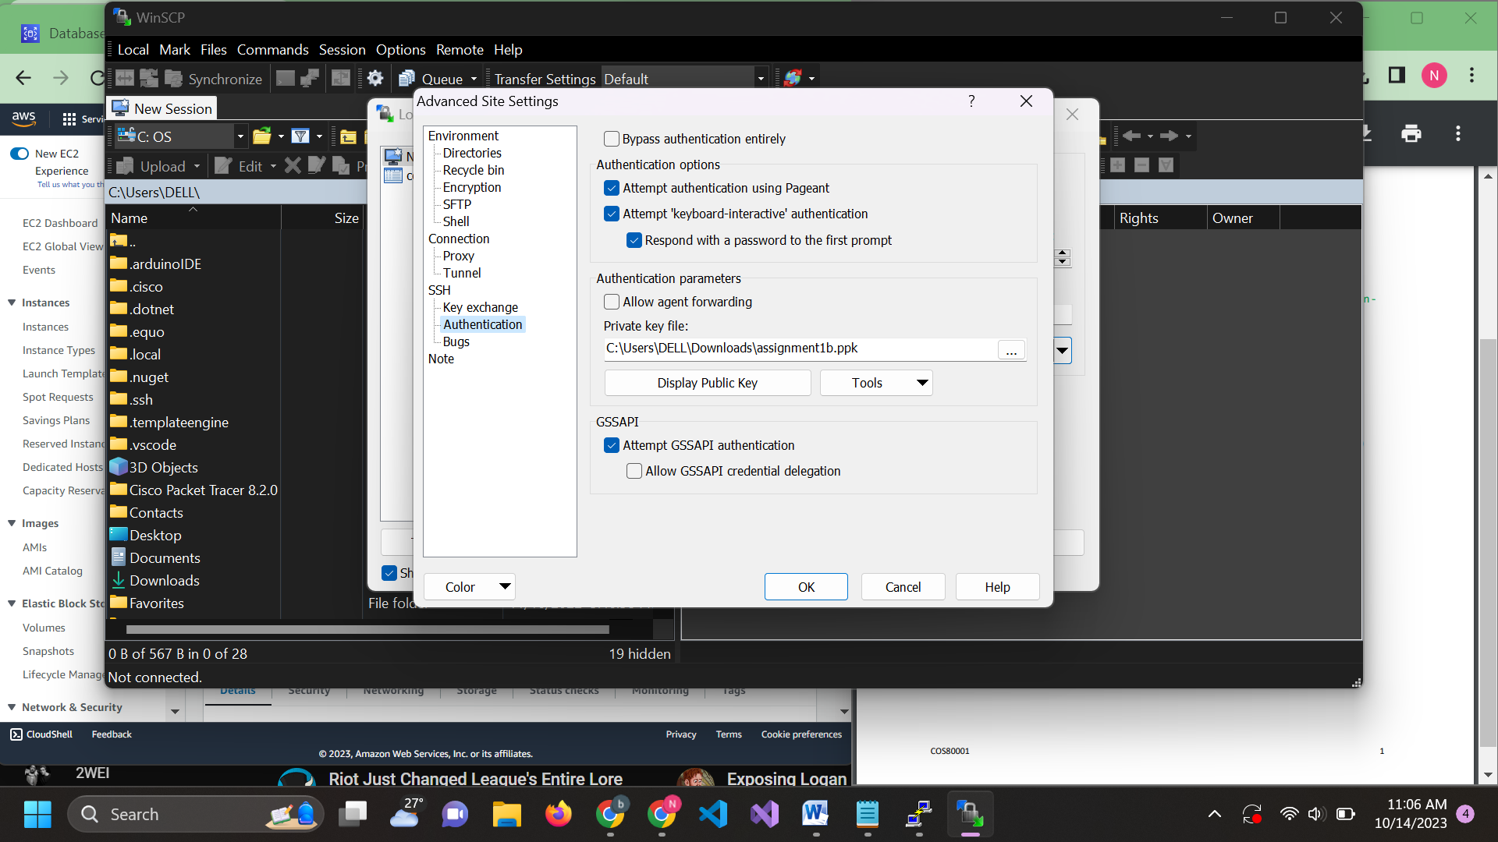

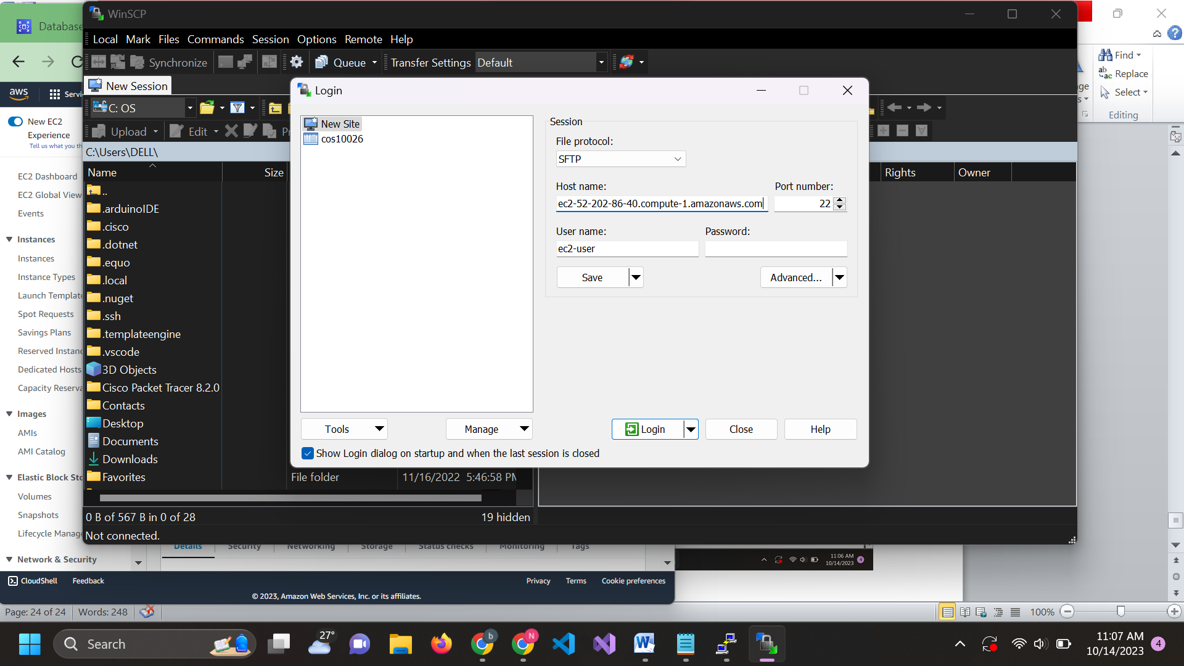

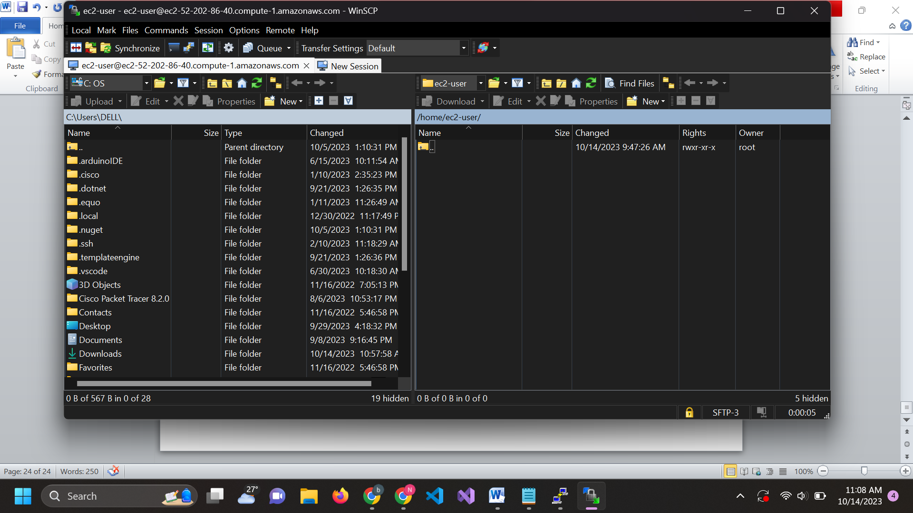

Access this directory

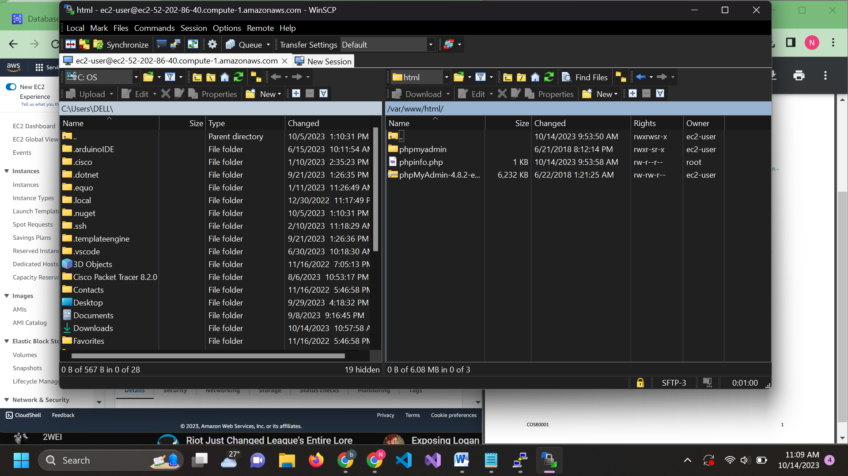

Change config.sample.inc.php to config.inc.php

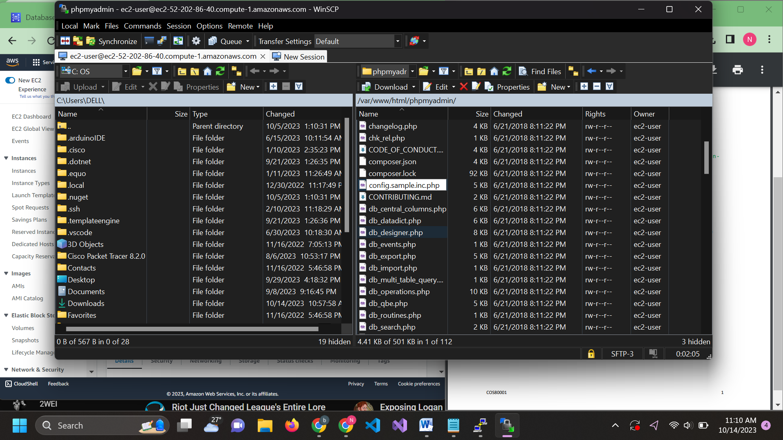

Change the code line from localhost to your rds endpoint

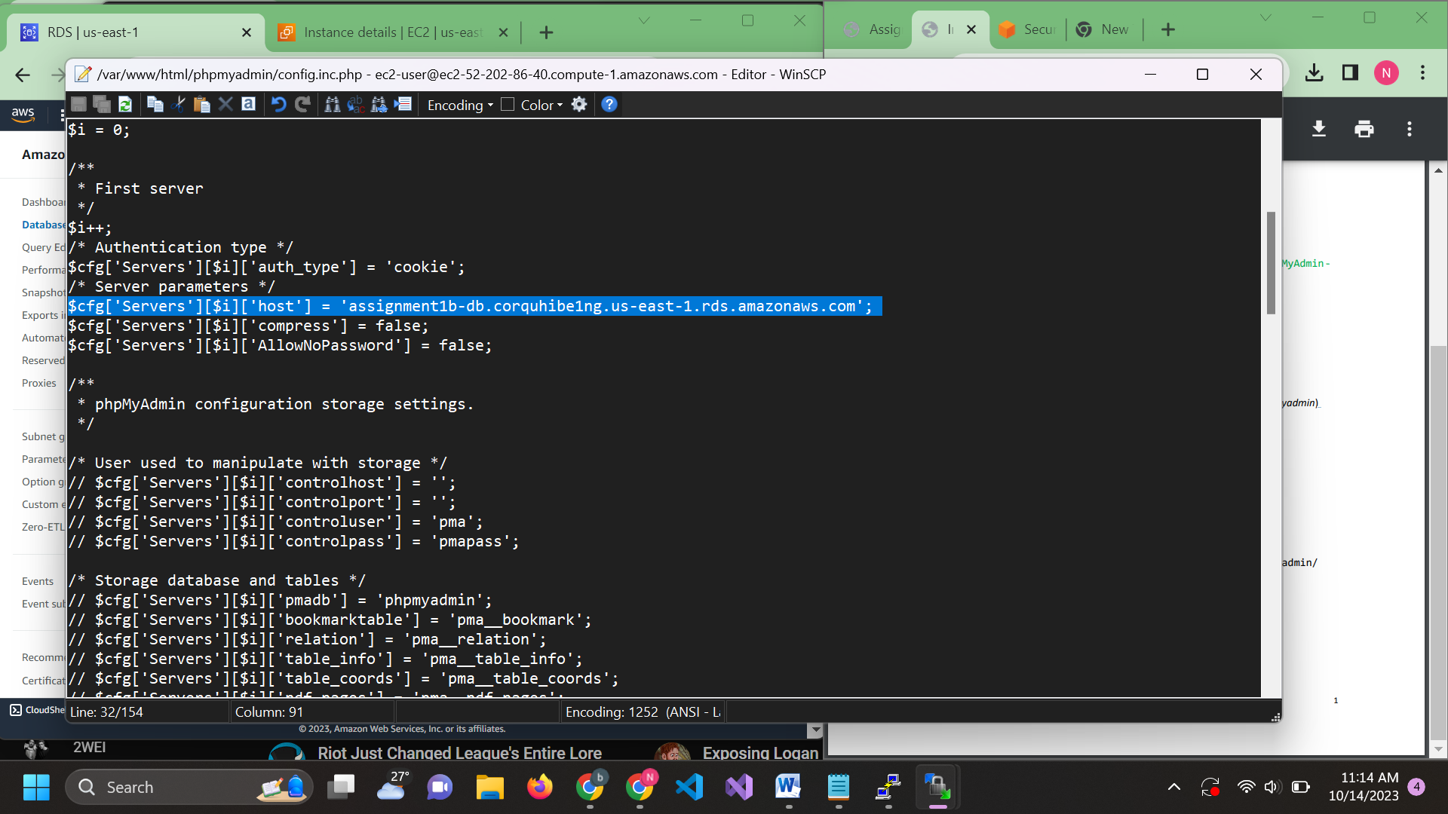

Enter using your public dns to test if it working(I’m not sure why I don’t have to enter password for my rds)

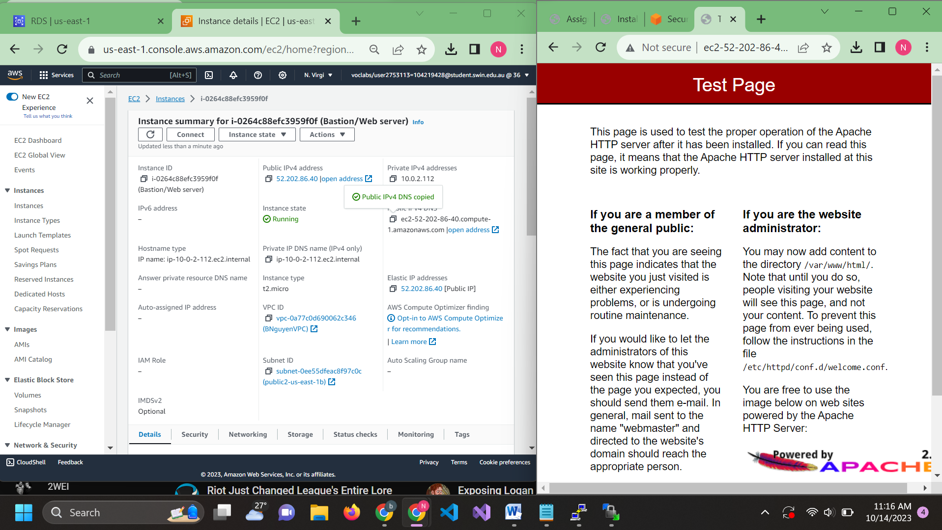

Endpoint link with /phpmyadmin : http://ec2-52-202-86-40.compute-1.amazonaws.com/phpmyadmin/

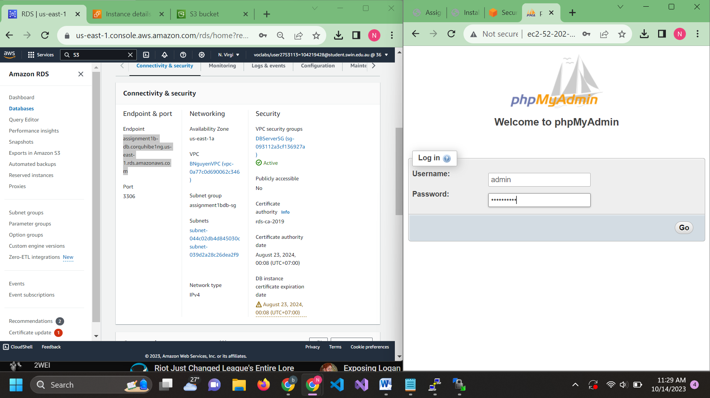

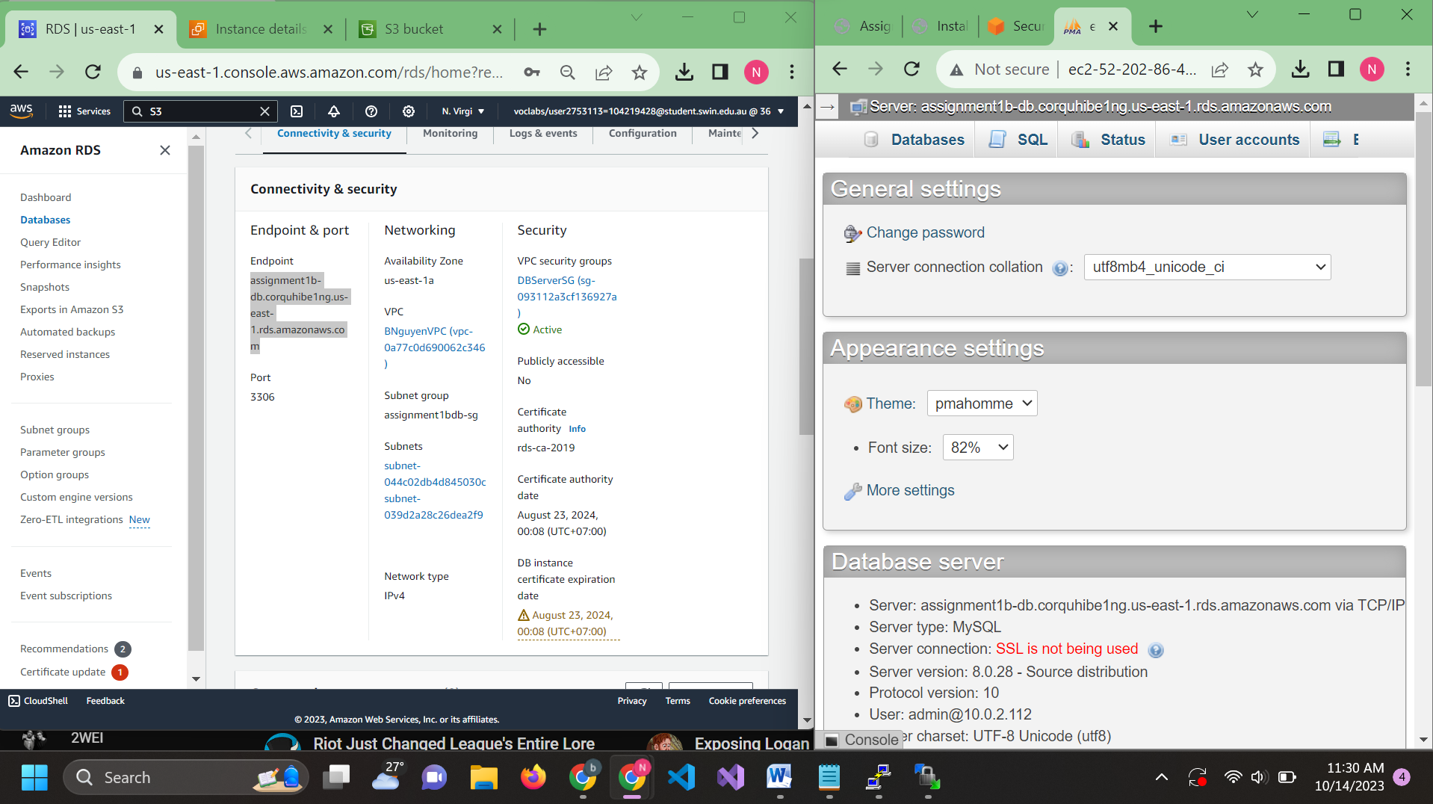

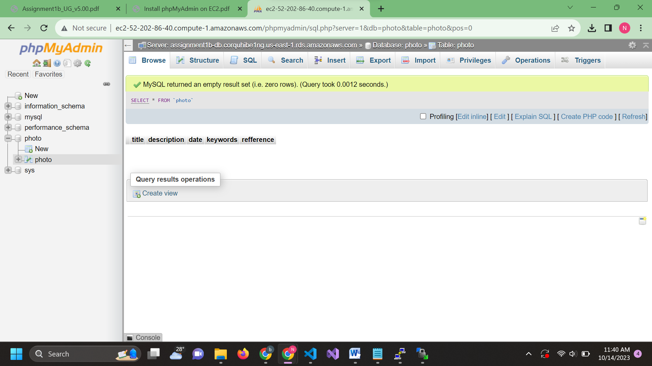

The table above is created using SQL command

CREATE TABLE photo (

title VARCHAR(255),

description VARCHAR(255),

date DATE

keywords VARCHAR(255),

refference VARCHAR(255),

);

Step 6: Create S3 bucket

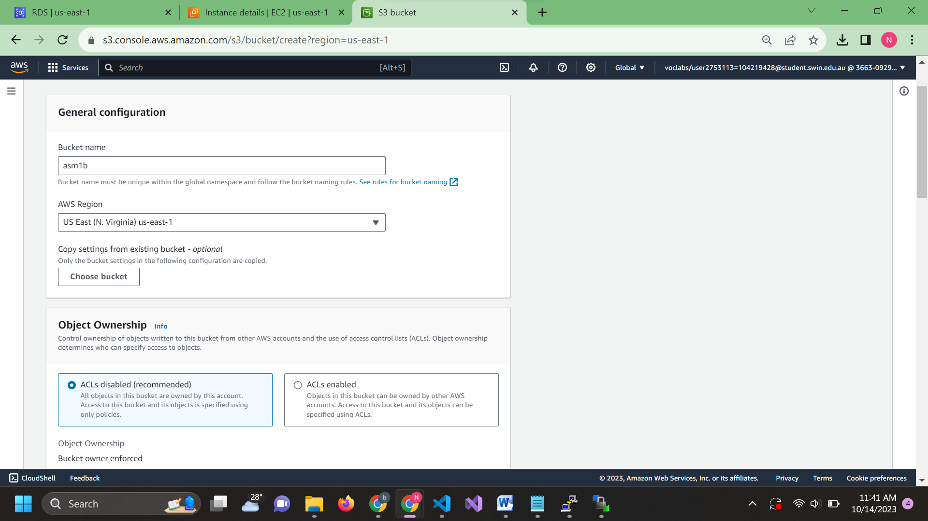 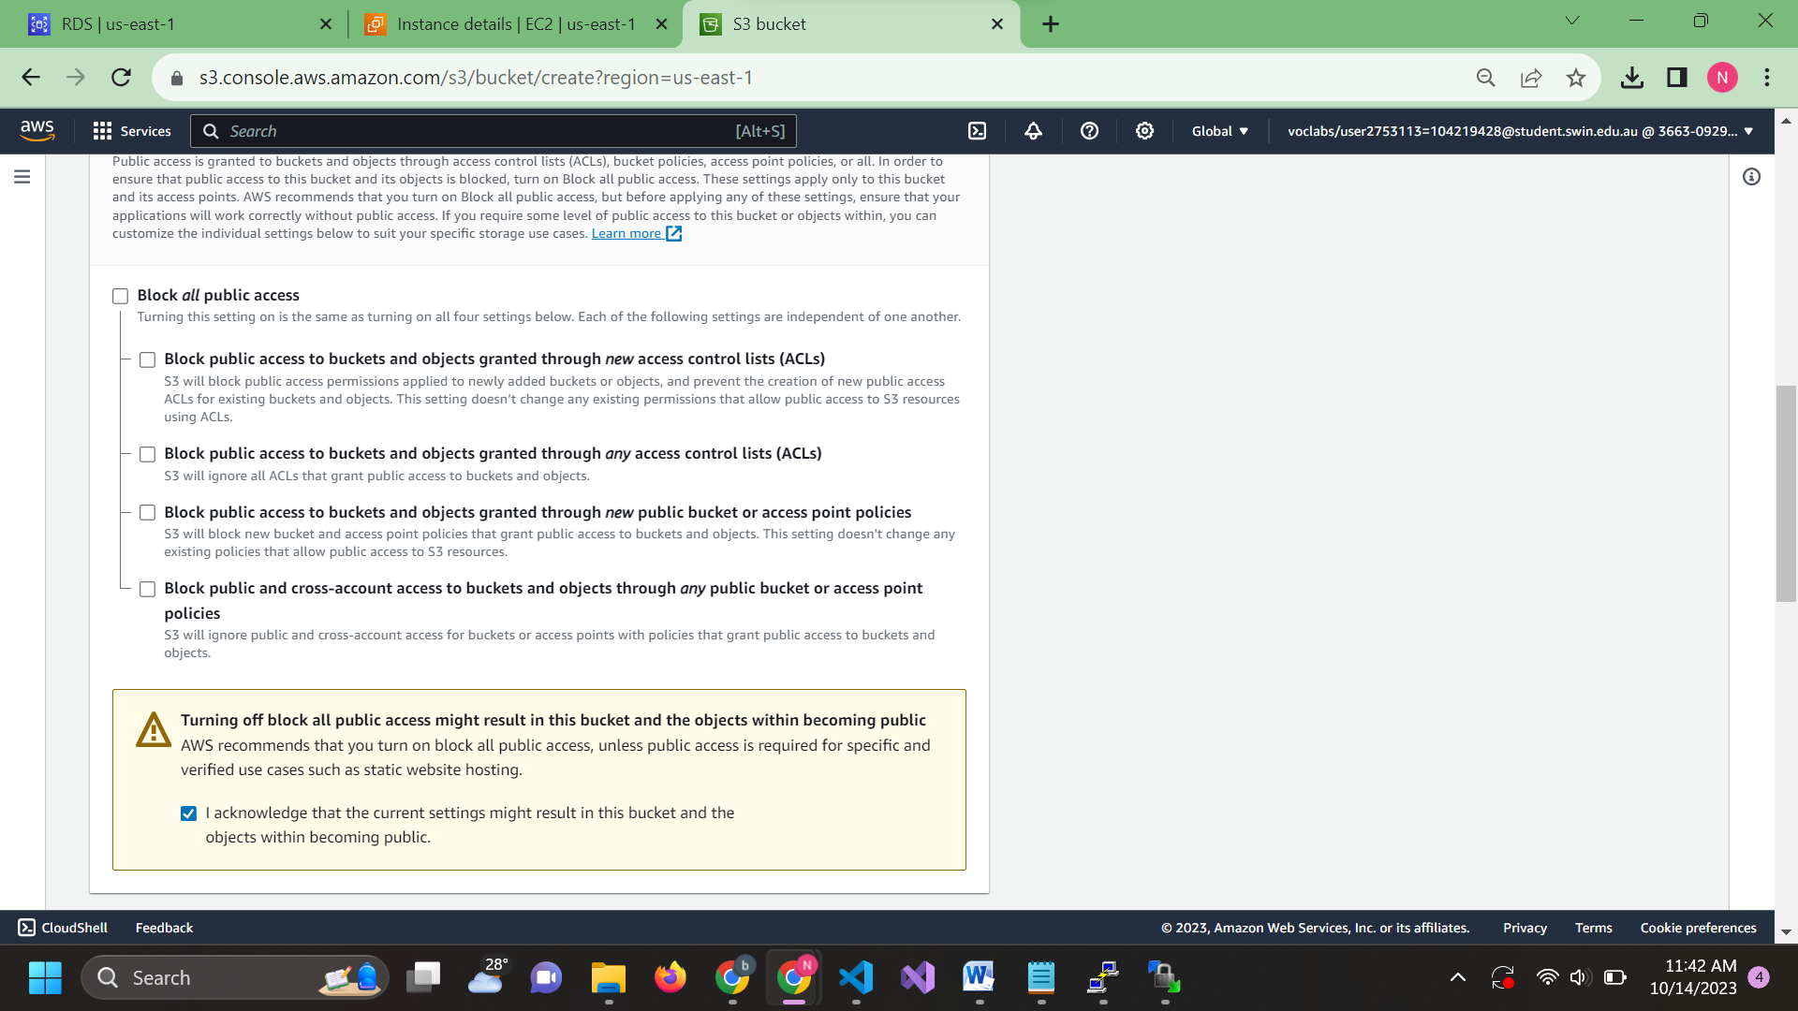

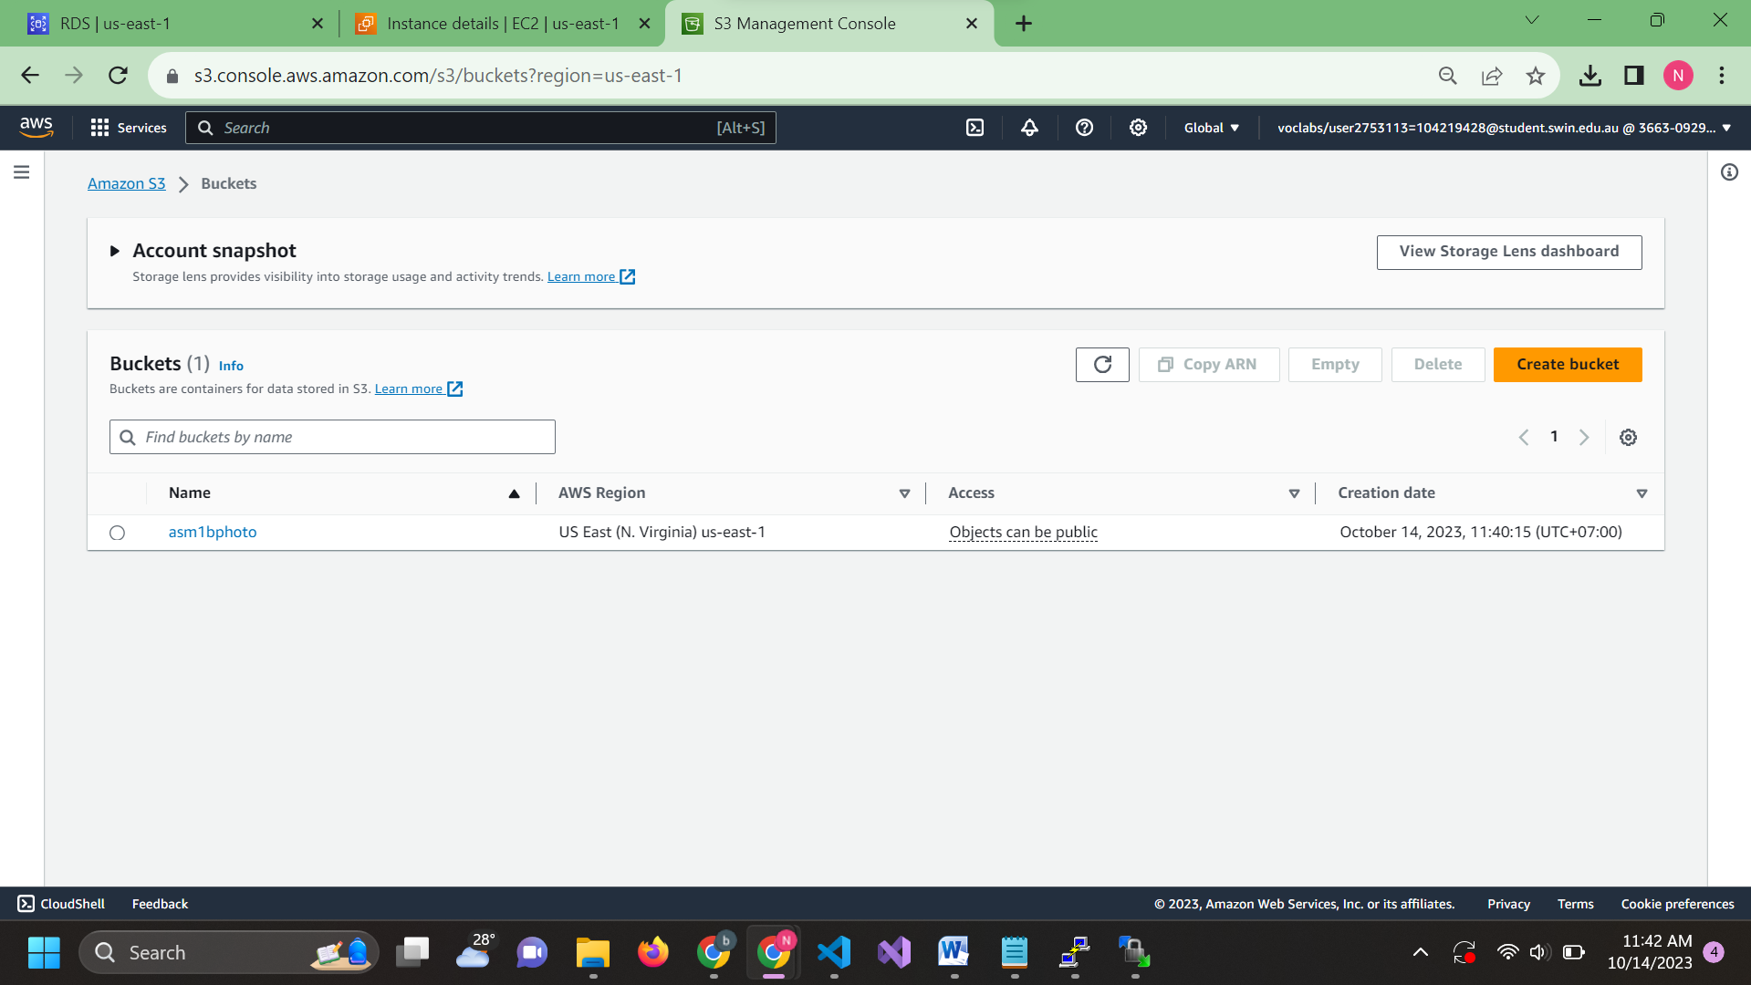

Step 7: Create network ACLs

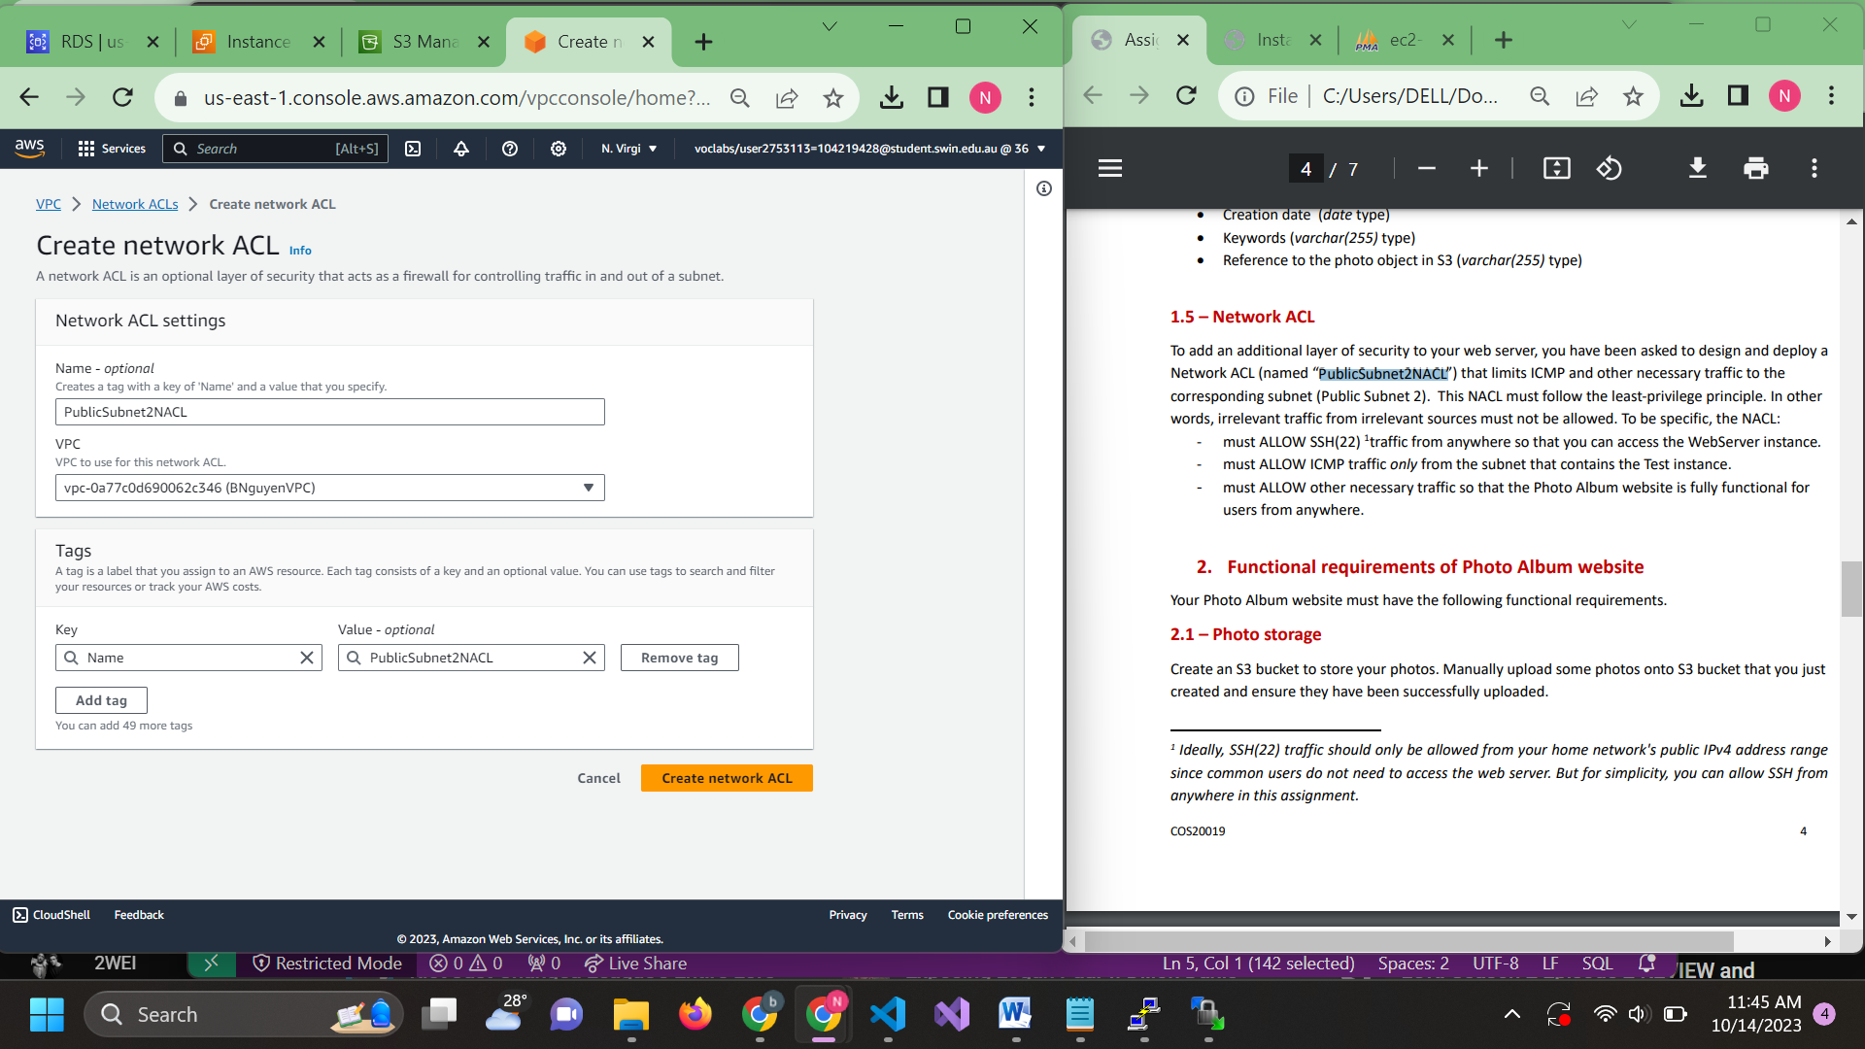

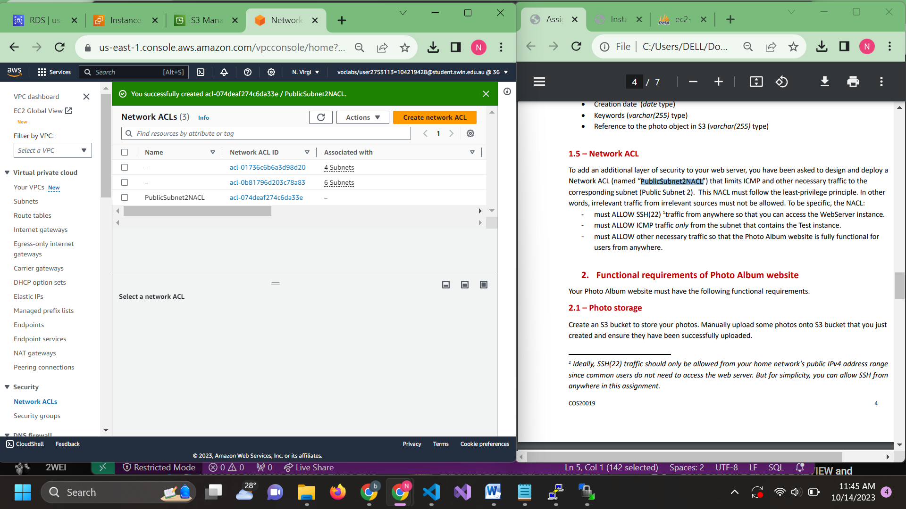

Choose the Network acl you created and go into Action to edit inbound/outbound and subnet association so it can be access from anywhere

7.1: Inbound

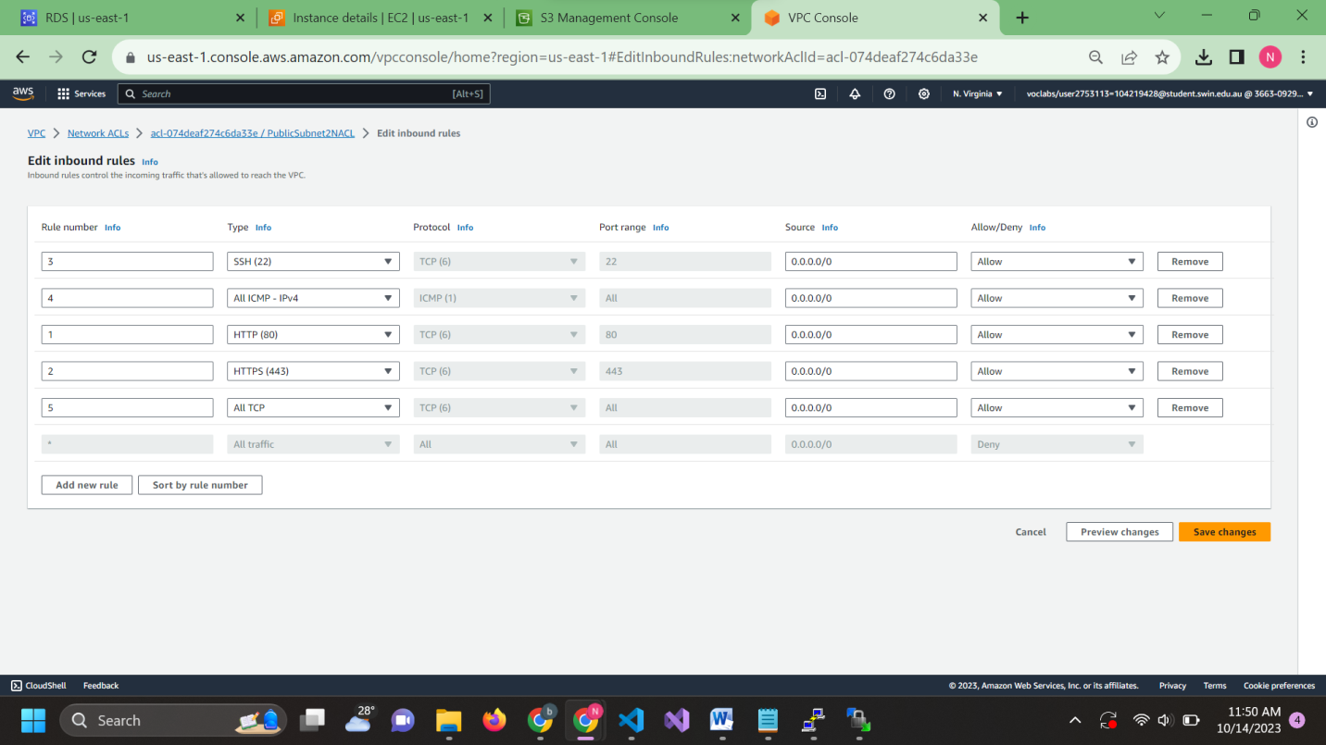

7.2: Outbound

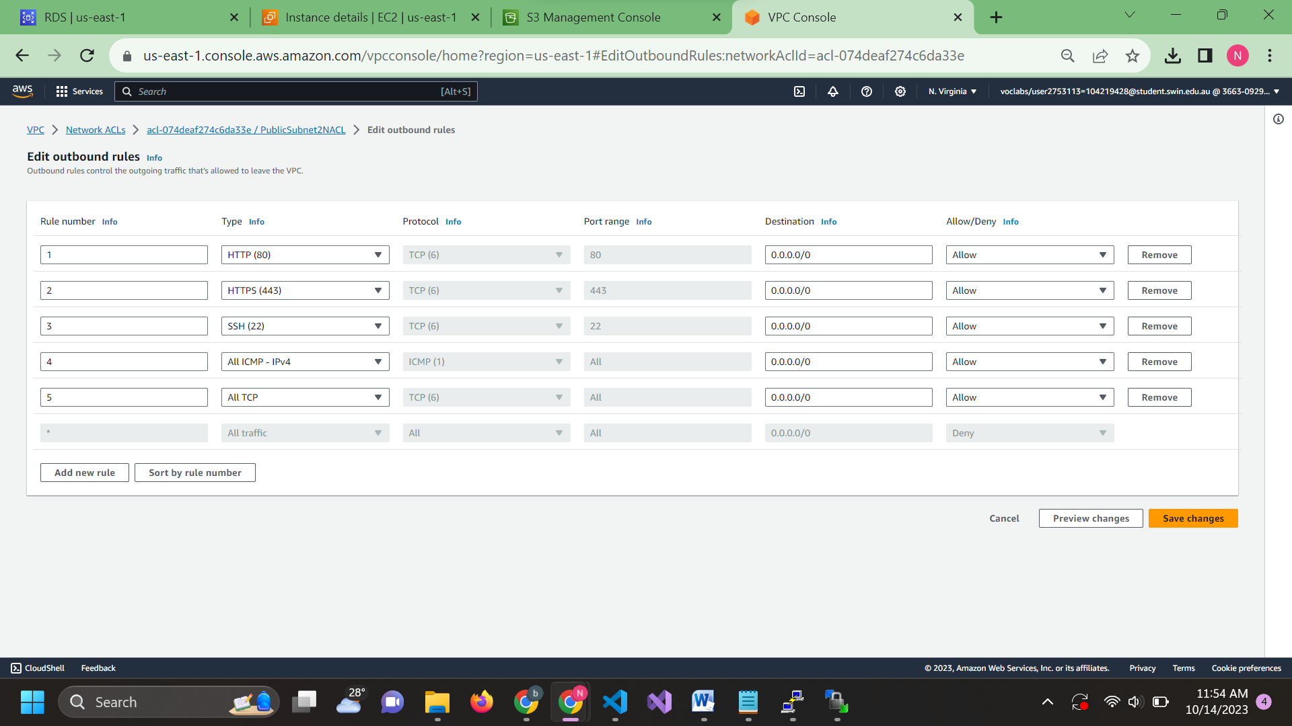

7.3: Subnet

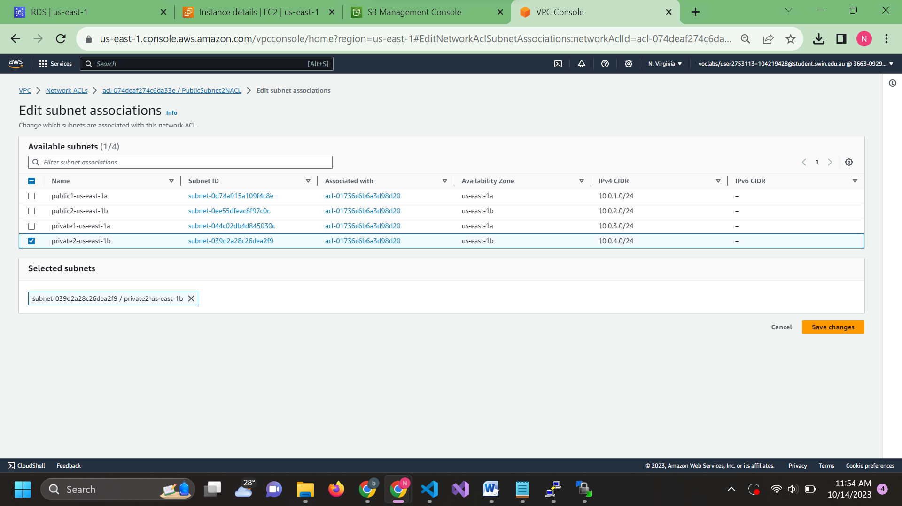

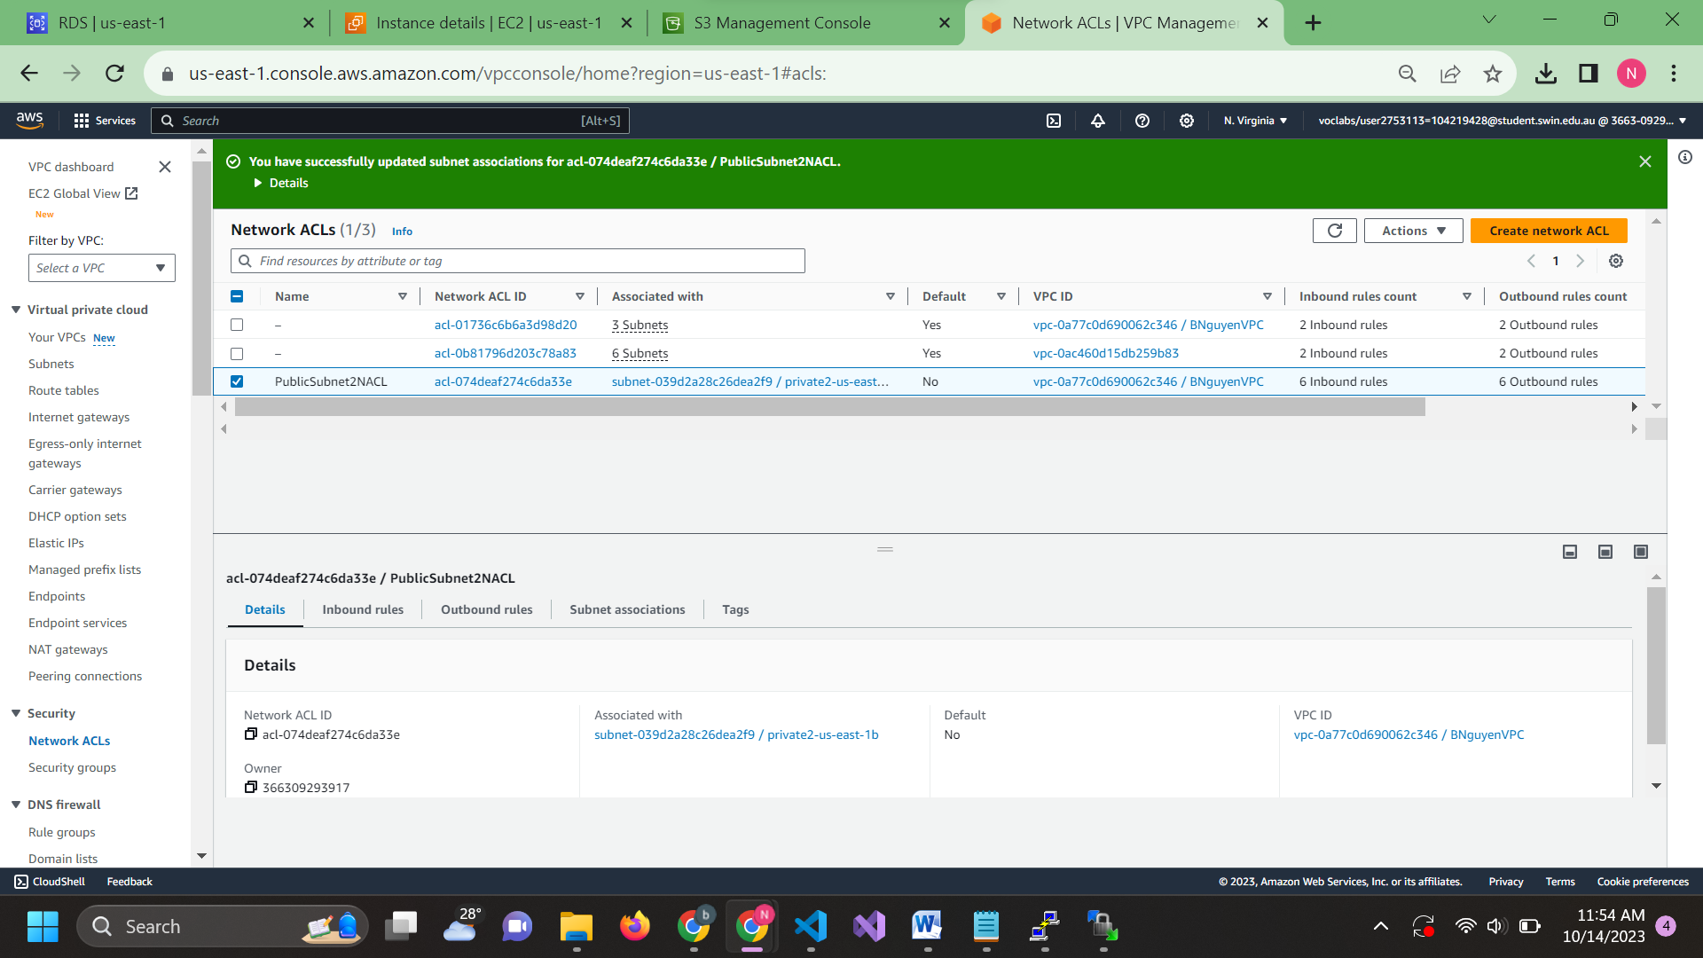

Step 8: upload photo into your S3 bucket

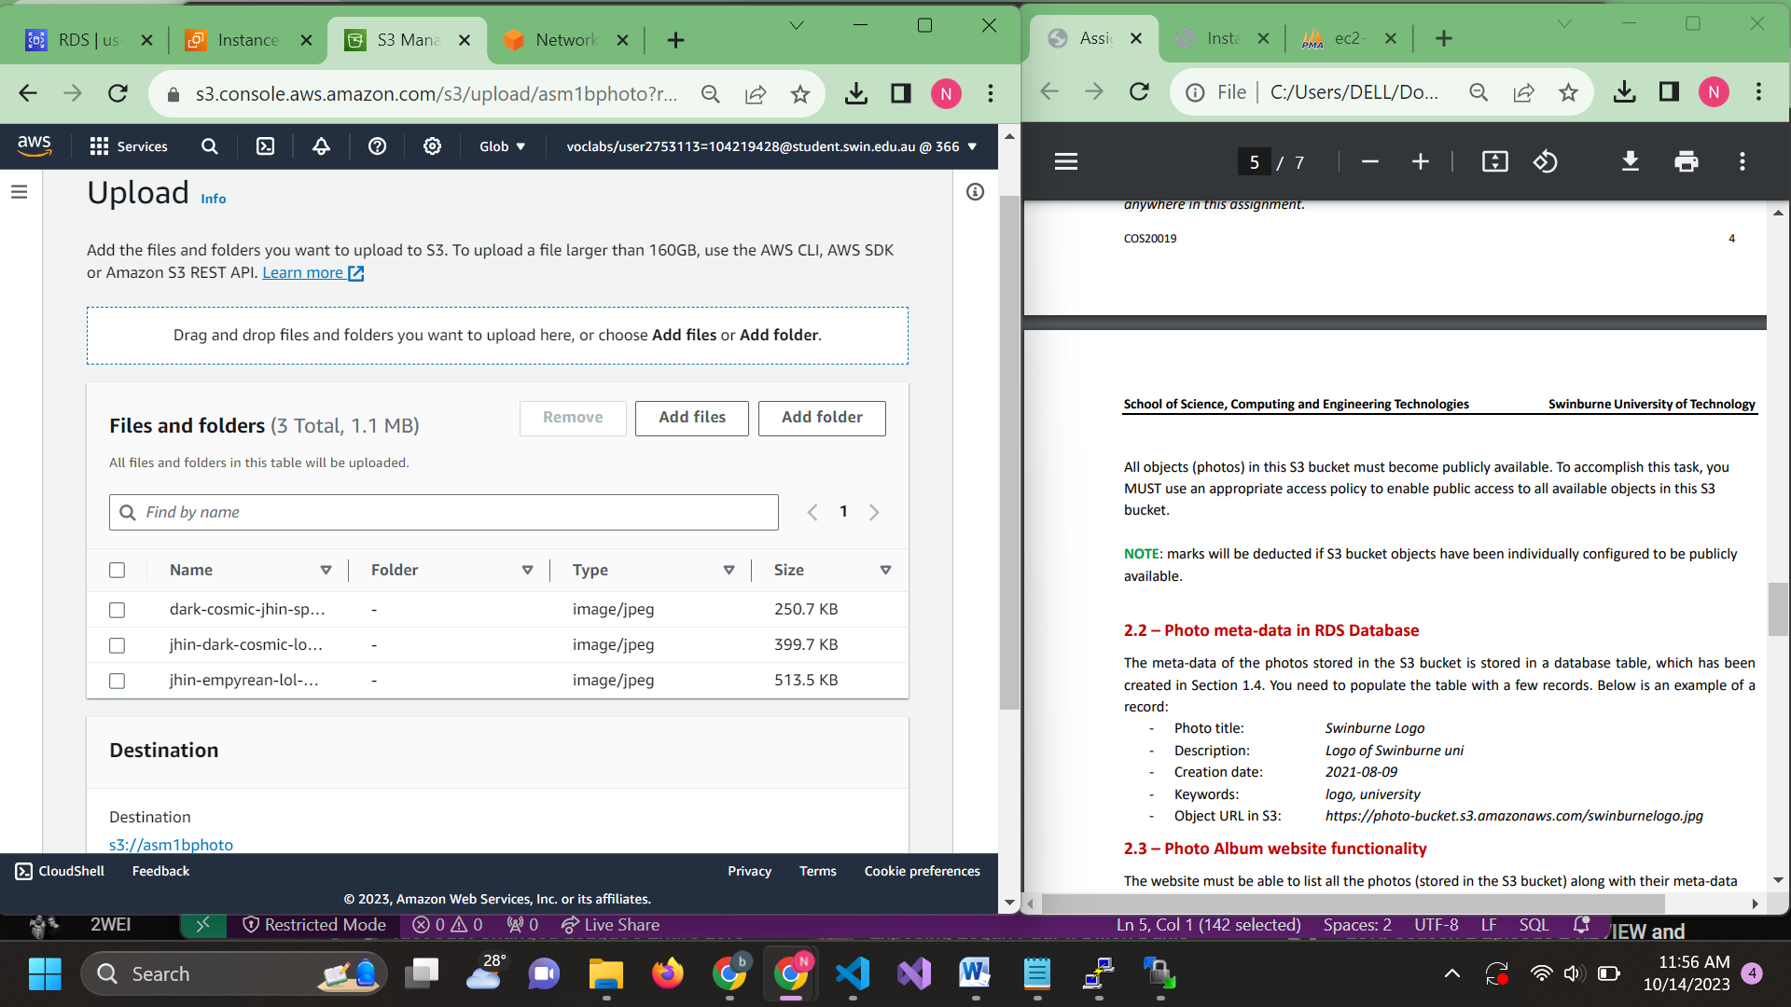

8.2: Edit bucket policy

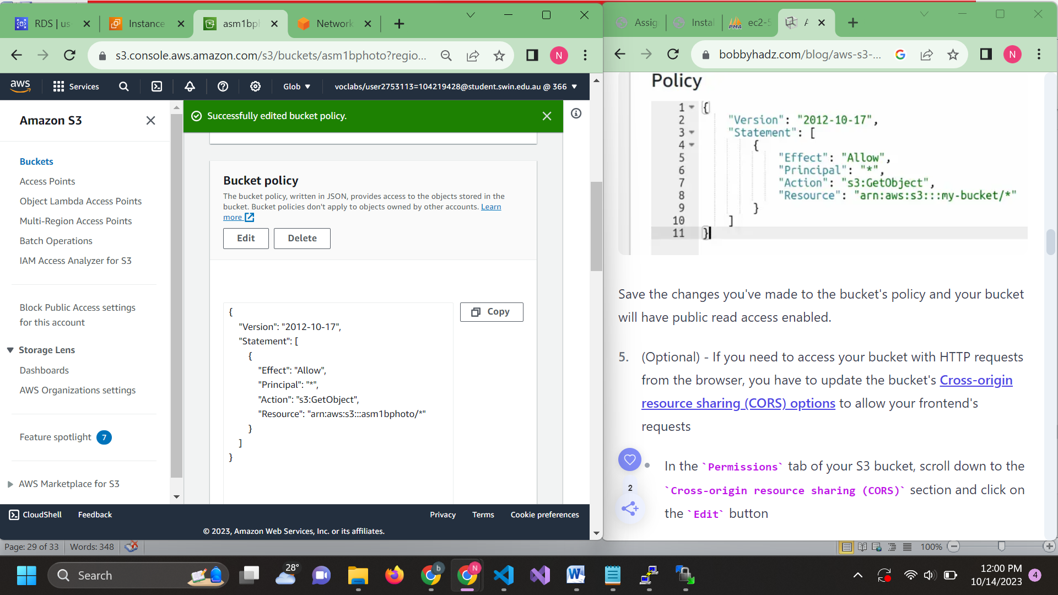

Step 9: Put your photo into the database to test it

9.1 copy photo url

https://asm1bphoto.s3.amazonaws.com/dark-cosmic-jhin-splash-art-lol-4K-87.jpg

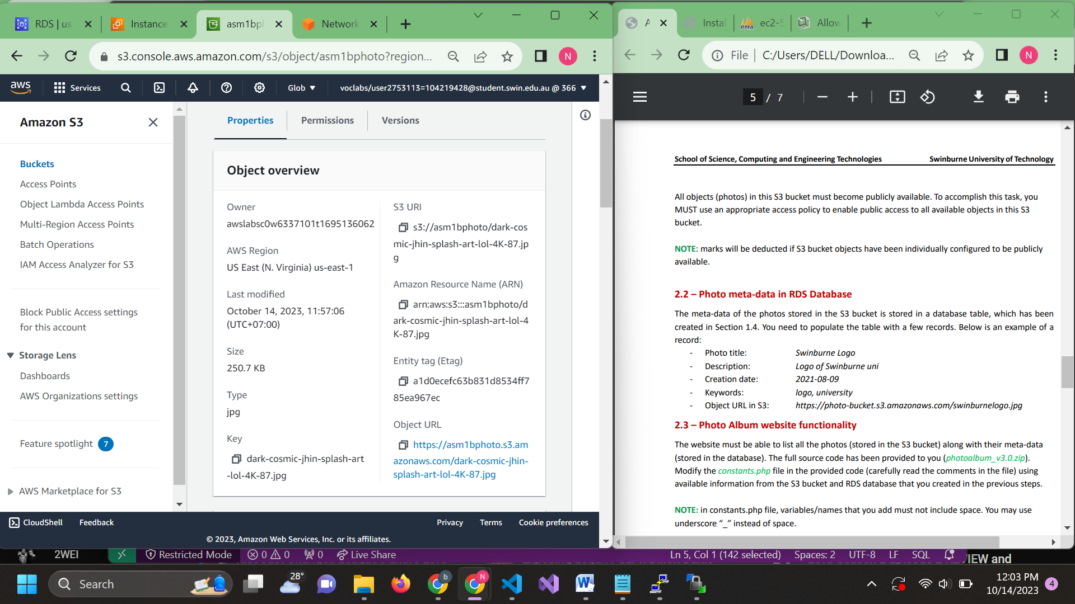

Insert it into the table in your database using sql

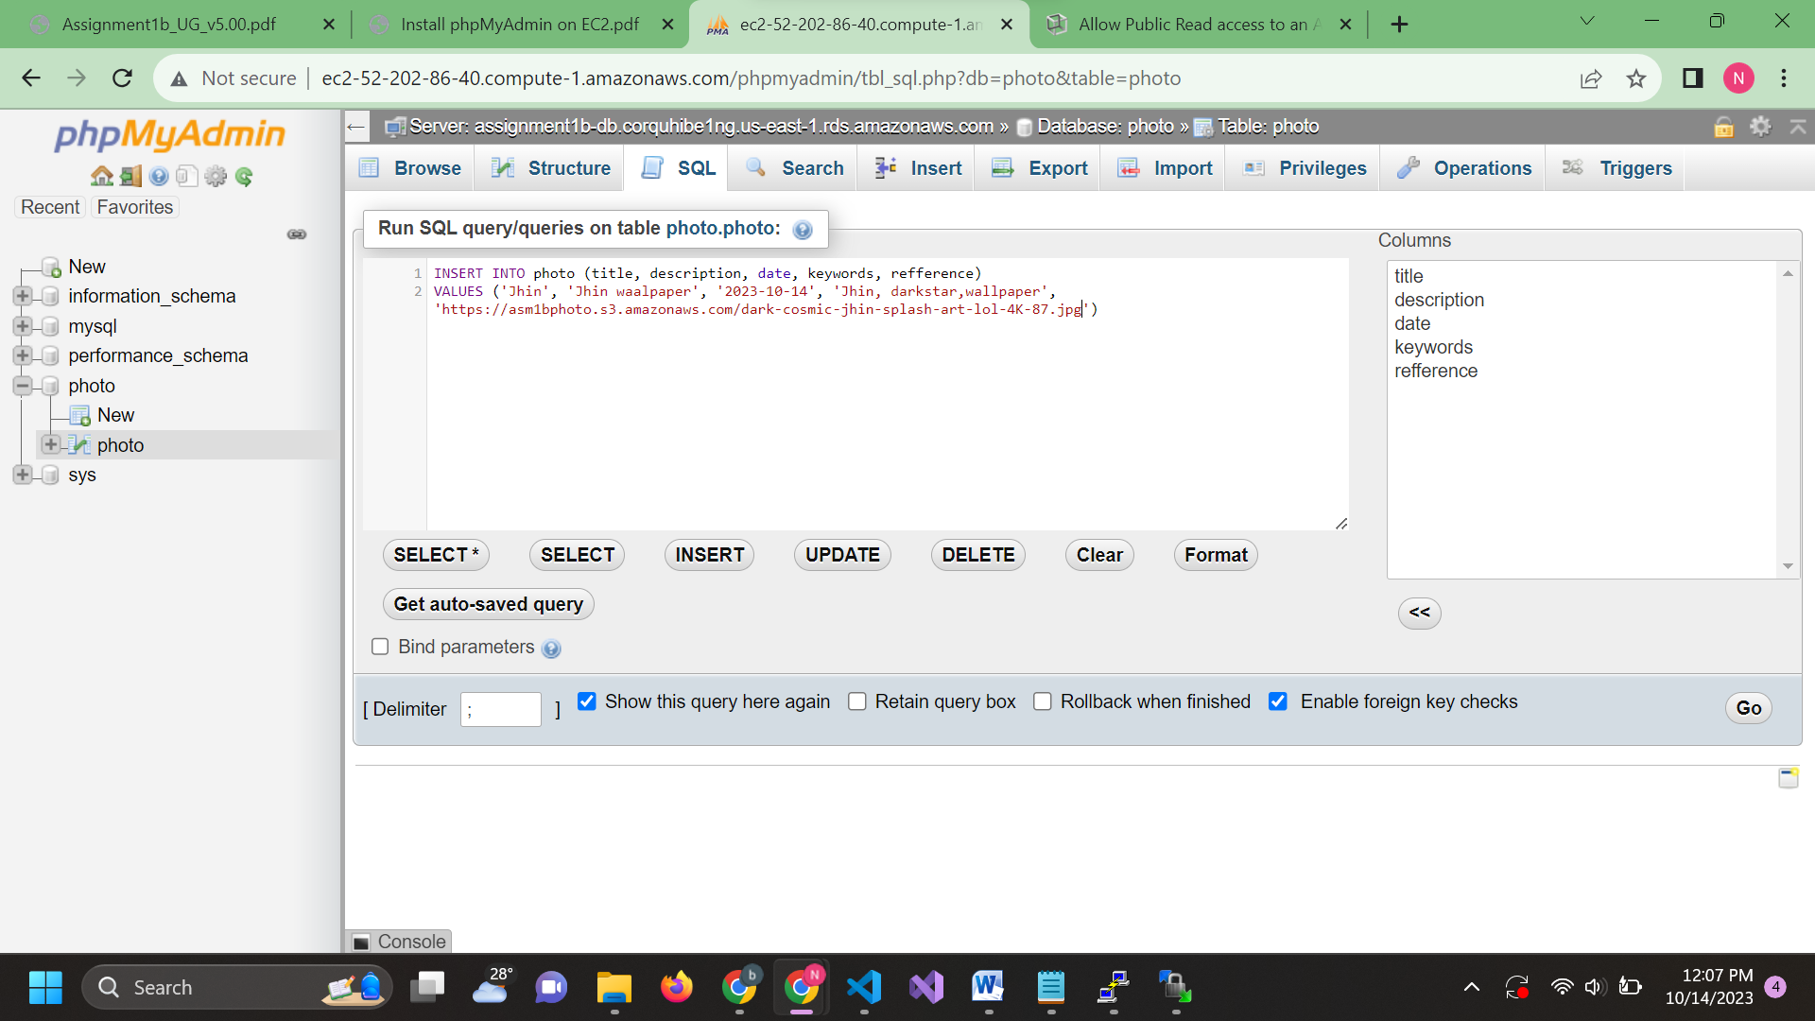

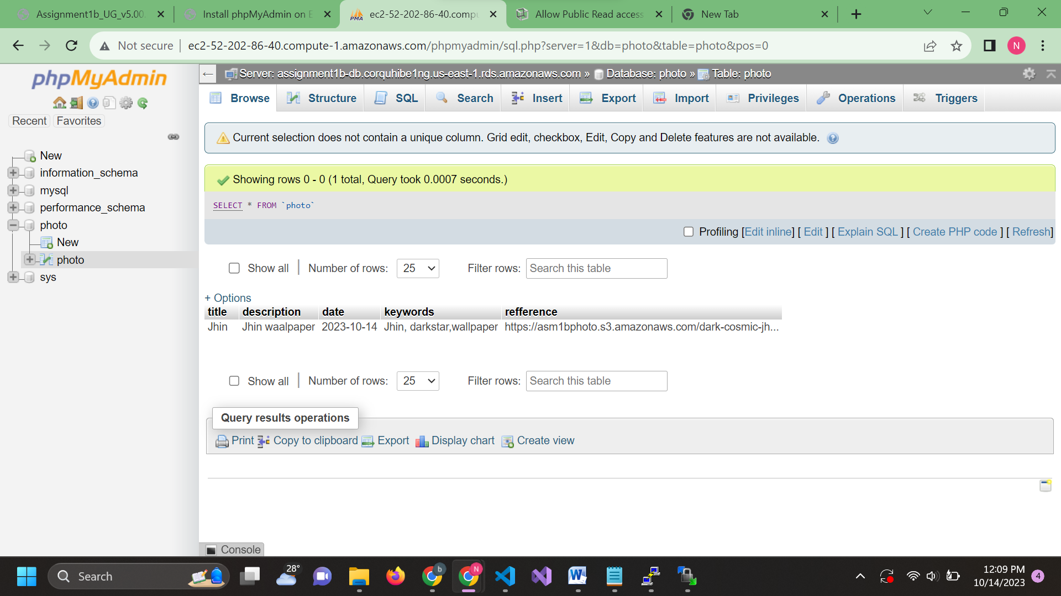

Edit constant.php

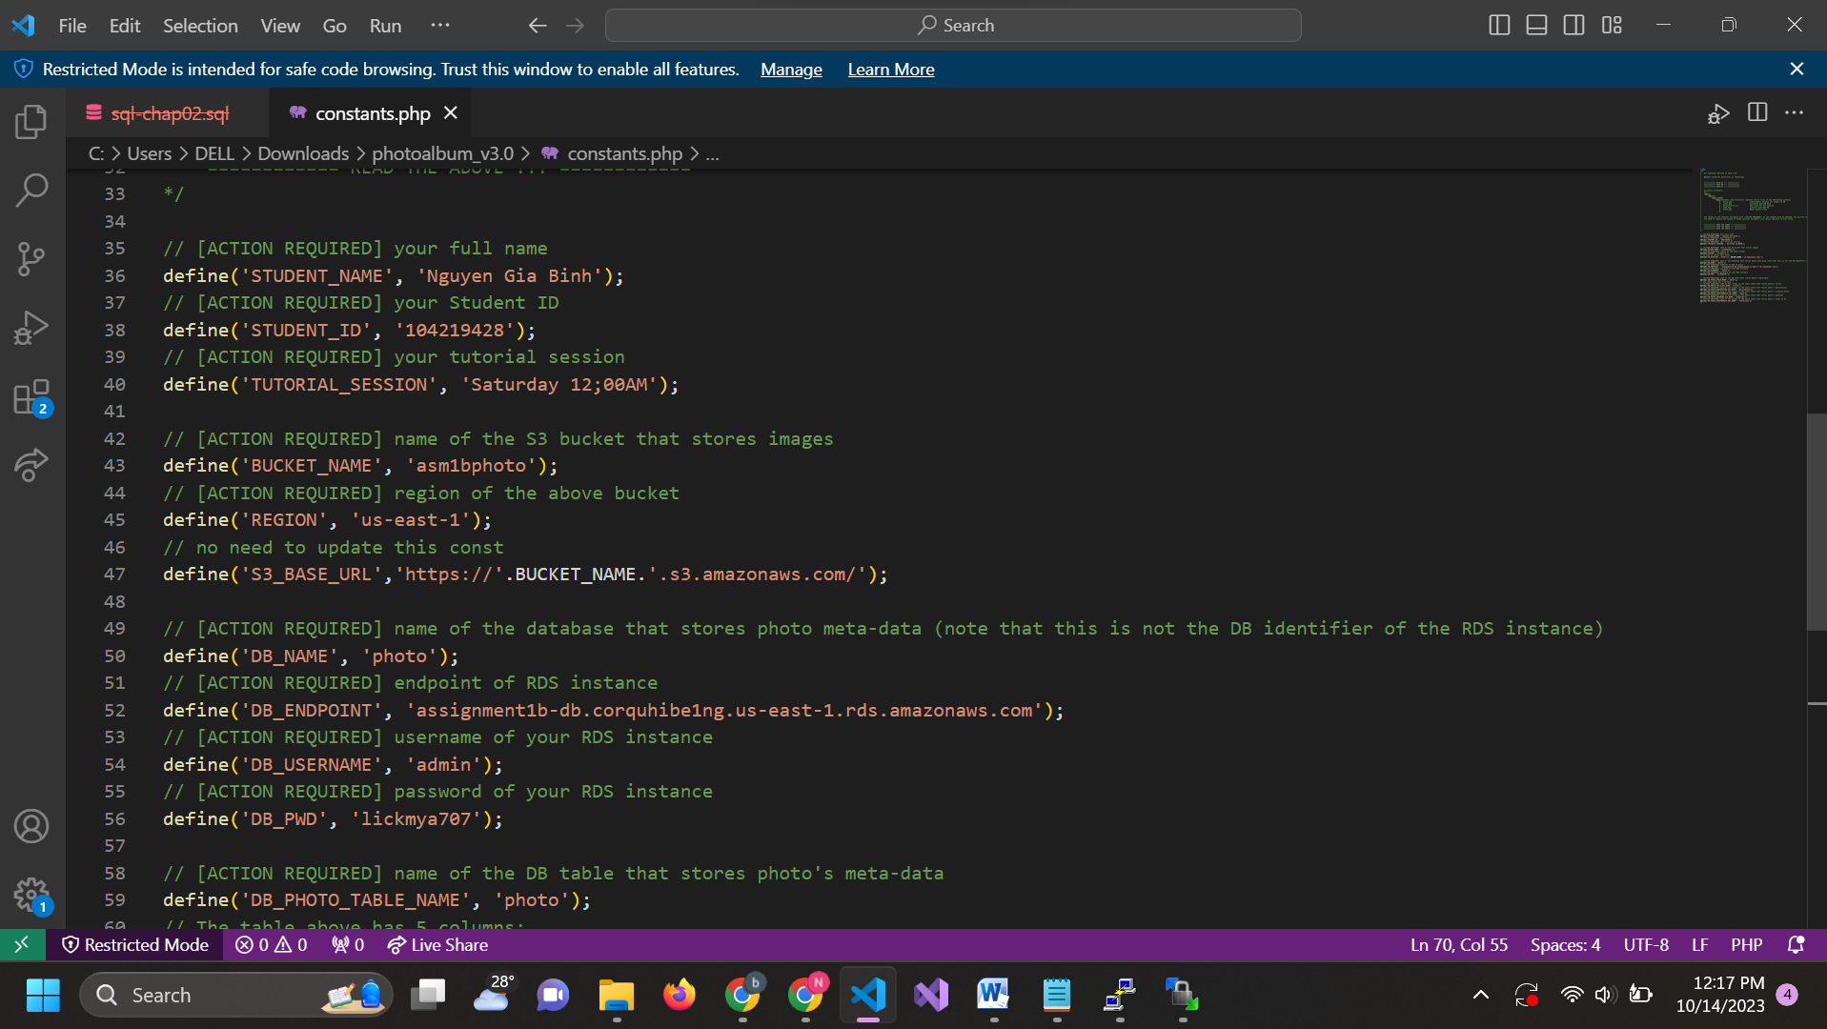

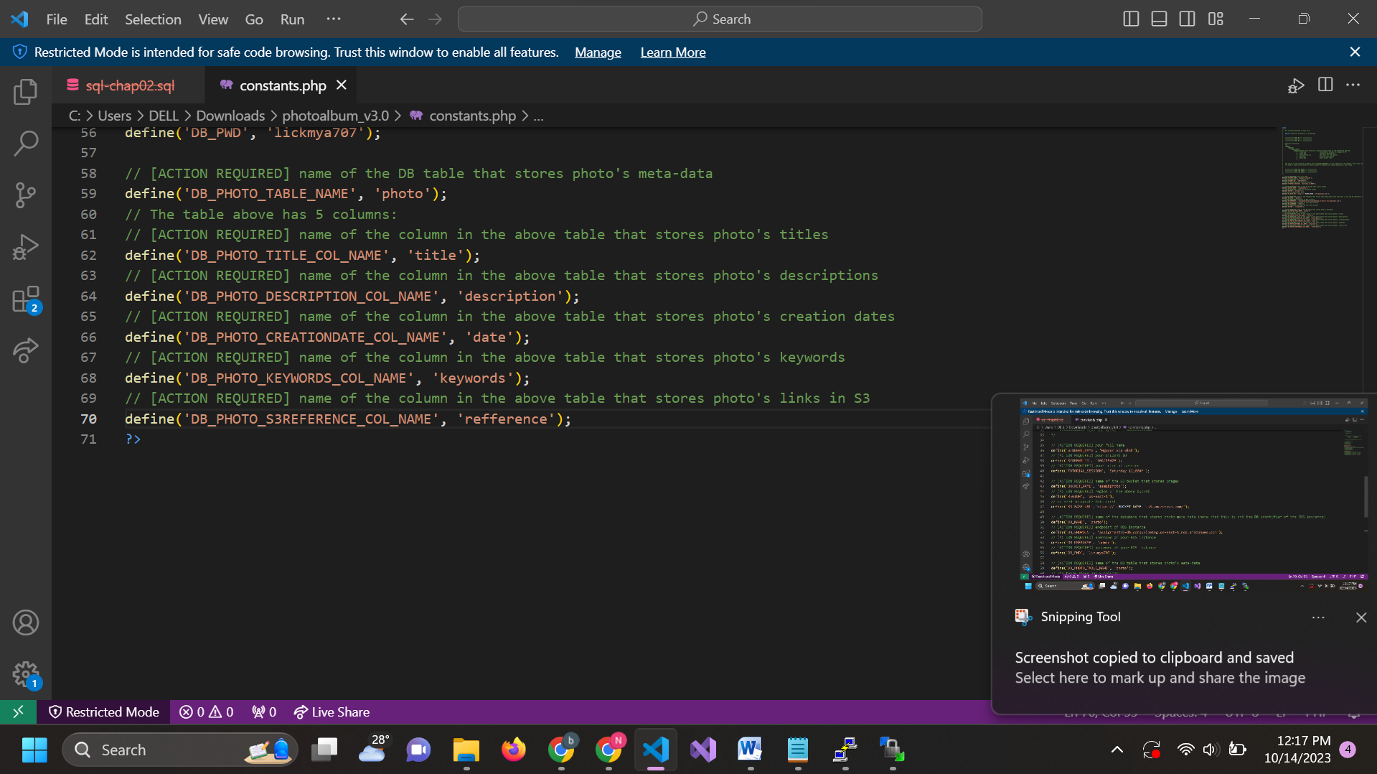

Upload files to your bucket

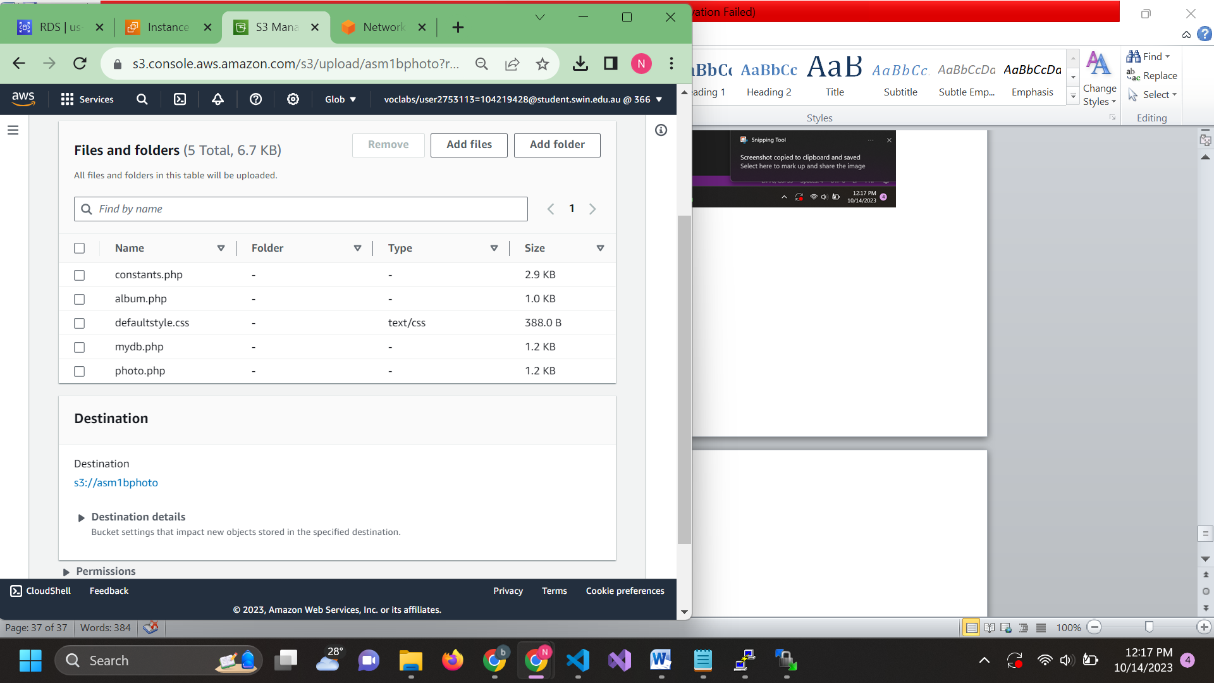

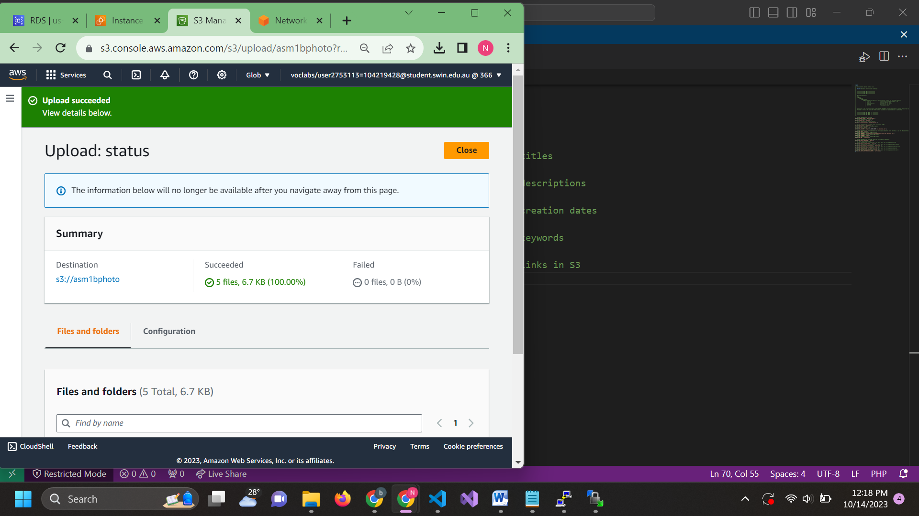

Upload the files into the directory in WinSCP

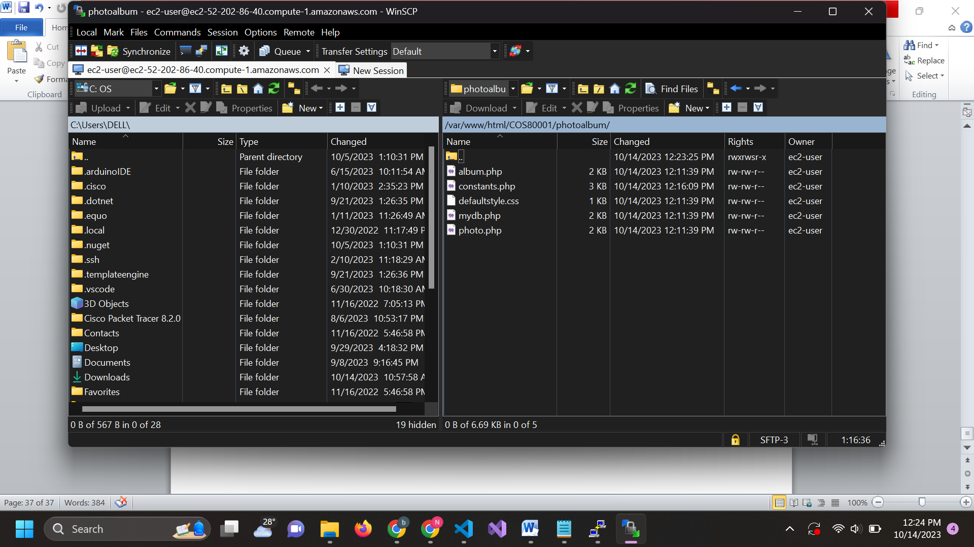

Access it through your local brower using Bastion public DNS

http://ec2-52-202-86-40.compute-1.amazonaws.com/COS80001/photoalbum/album.php

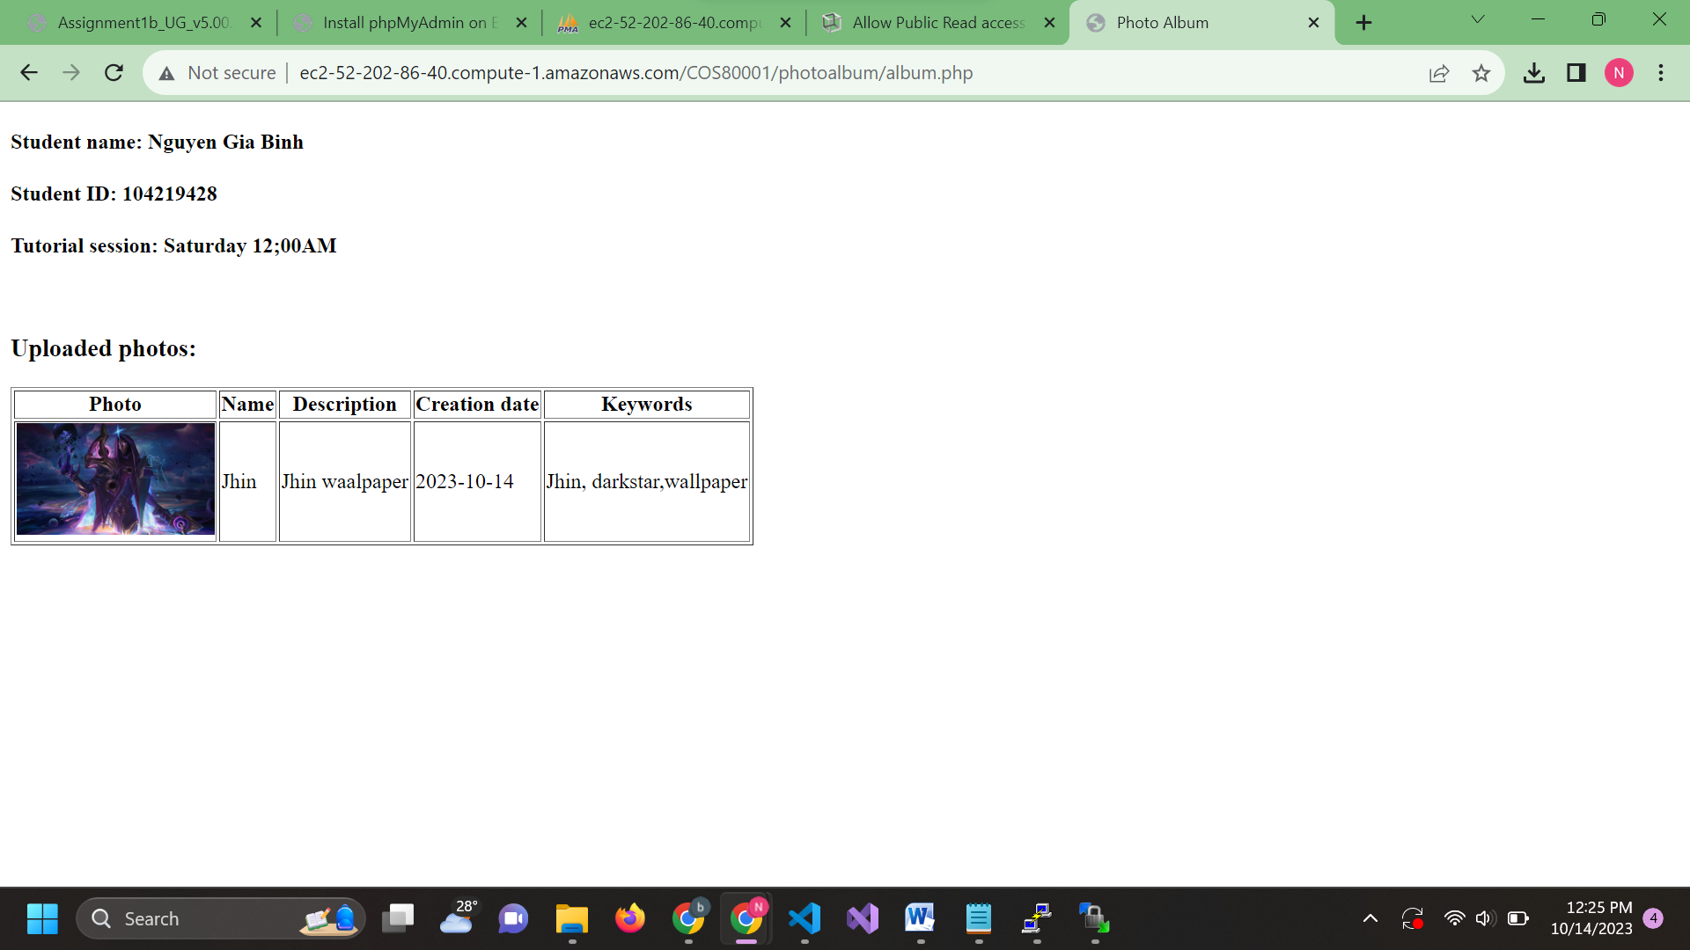

Step 10 : Ping Test from Bastion (login using Bastion public elastic IP, ssh Bastion private IP and ping Testinstance using it private Ipv4) (there is a change in Test Instance ipv4 because I accidentally delete it so I created it again)

